1. Normal Document

- Create Dataset

Select ‘Data set’ as following Fig.1-1.

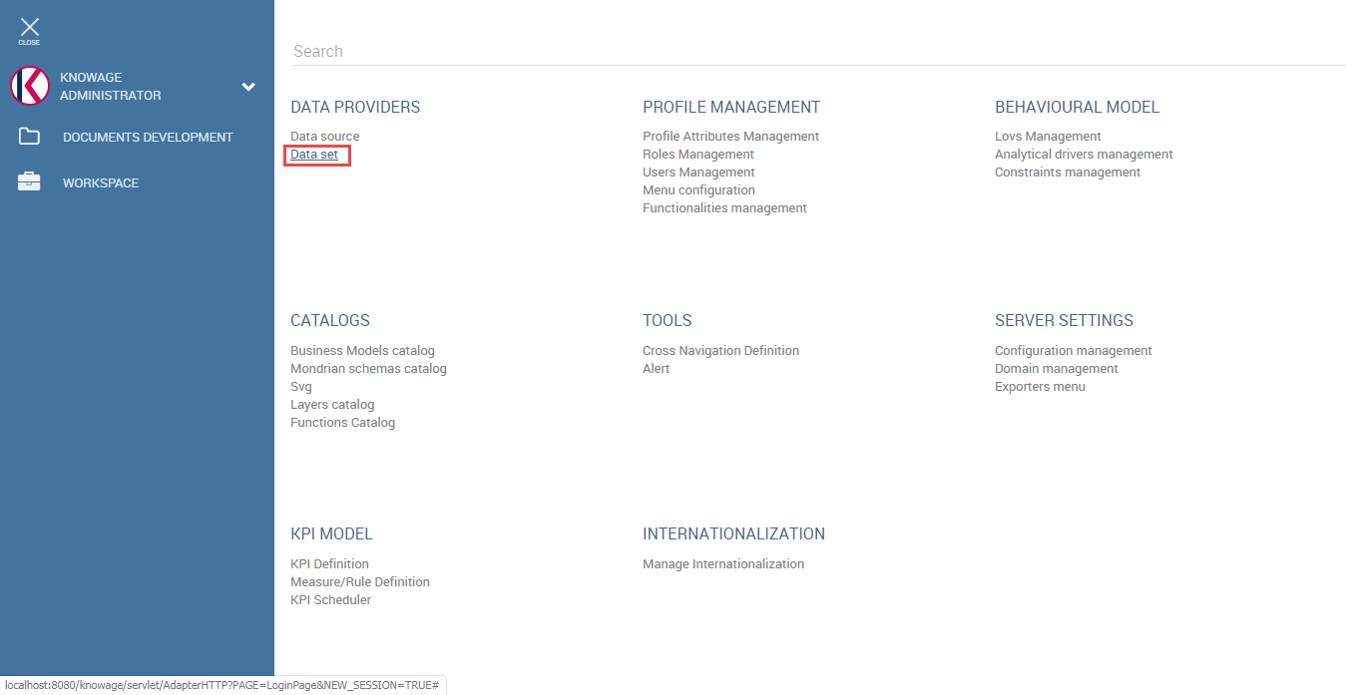

Fig.1-1 Select dataset

Create dataset as following Fig.1-2.

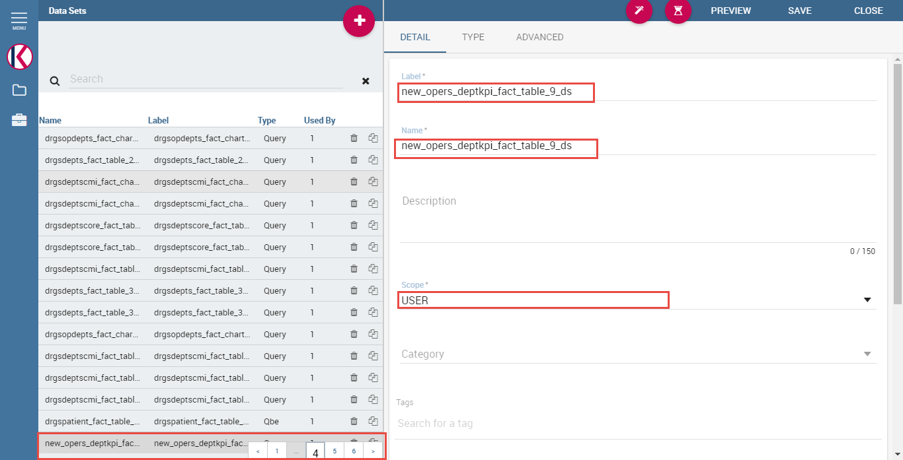

Fig.1-2 Create dataset

Select dataset type as ‘Query’ and data source and input query as following Fig.1-3.

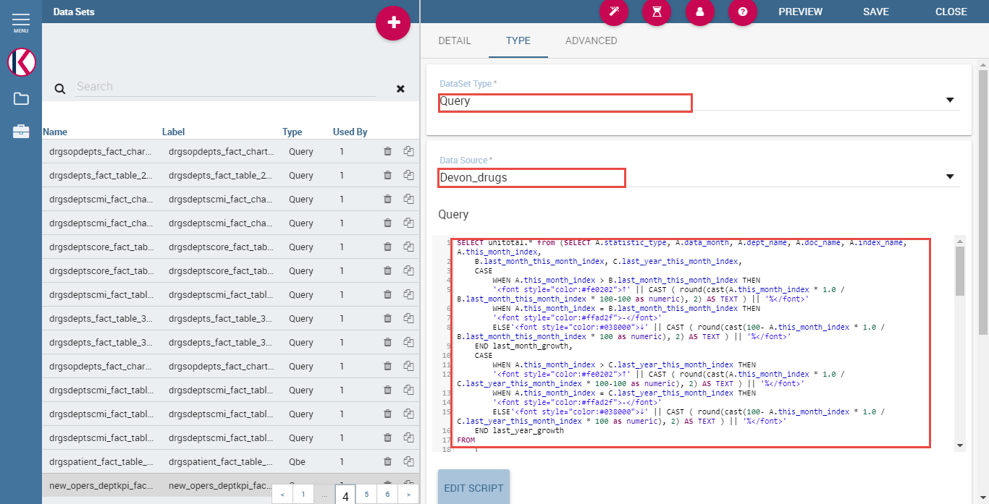

Fig.1-3 Customize dataset

Add parameters as following Fig.1-4.

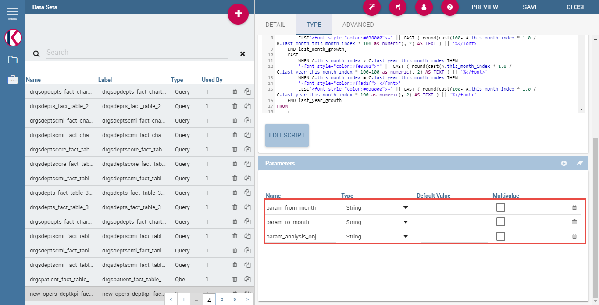

Fig.1-4 Add parameters for dataset

Create dataset for benchmark data same way as above too.

- Create LOV(List of values)s

Select ‘Lovs Management’ as following Fig.1-5.

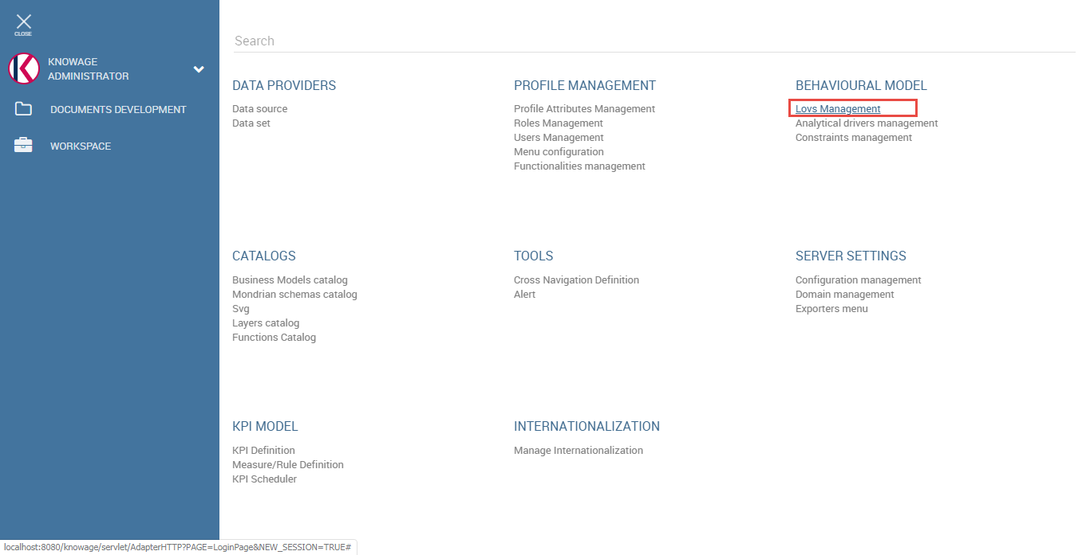

Fig.1-5 Select lovs management

Create Lov as following Fig.1-6.

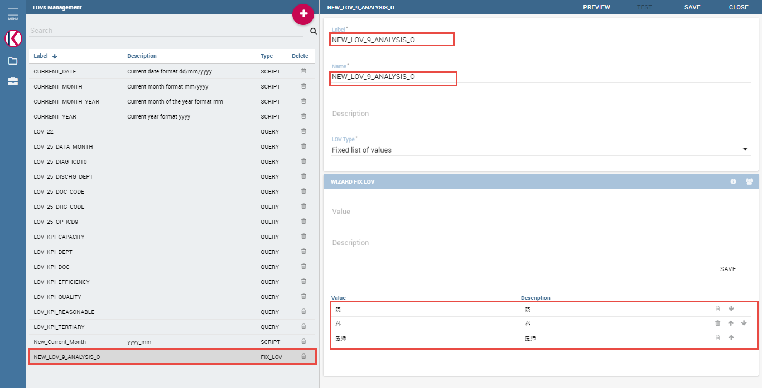

Fig.1-6 Create lov with ‘Fixed list of values’ type

Press ‘PREVIEW’ on the right top of the screen, then the ‘TEST’ button will be activated.

After the ‘TEST’ button is activated, please press it and set ‘Value’, ‘Description’ and ‘Visible’ as following Fig 1.7.

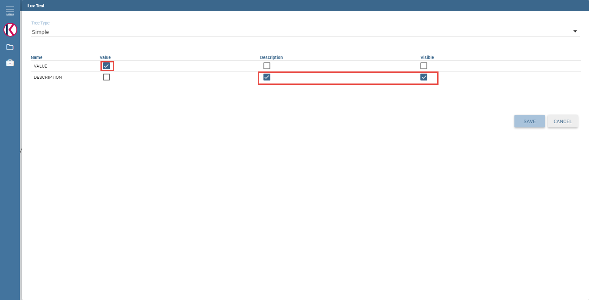

Fig.1-7 Customize Lov

Save the settings and save the lov too.

- Analytical drivers management for input parameters of document

Press ‘Analytical drivers management’ as following Fig.1-8.

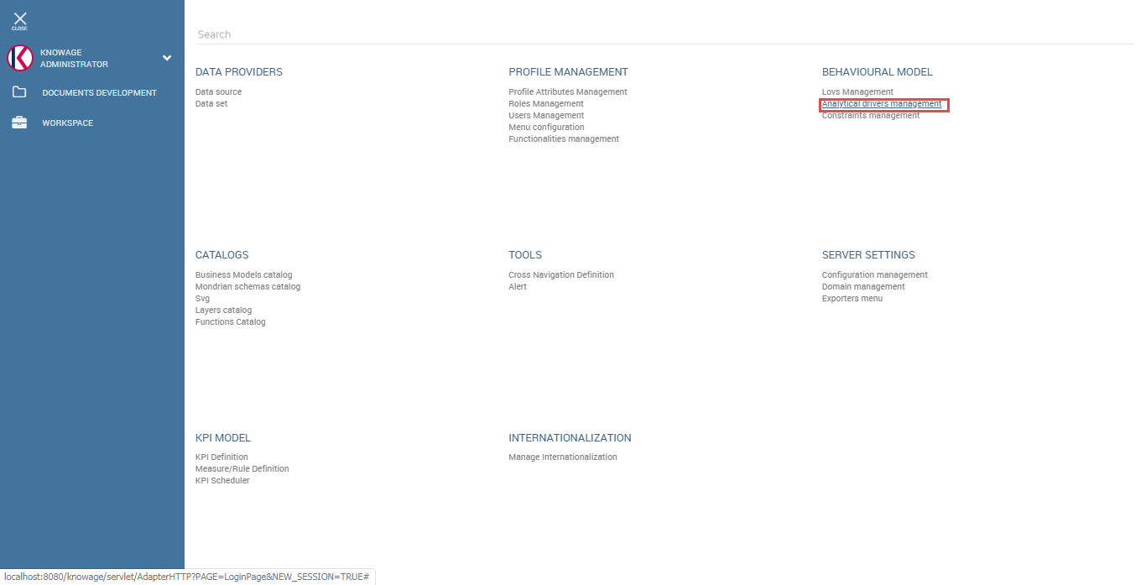

Fig.1-8 Analytical drivers management

Create 3 analytical drivers for document as following.

Add analytical driver for ‘From_Month’ parameter of document.

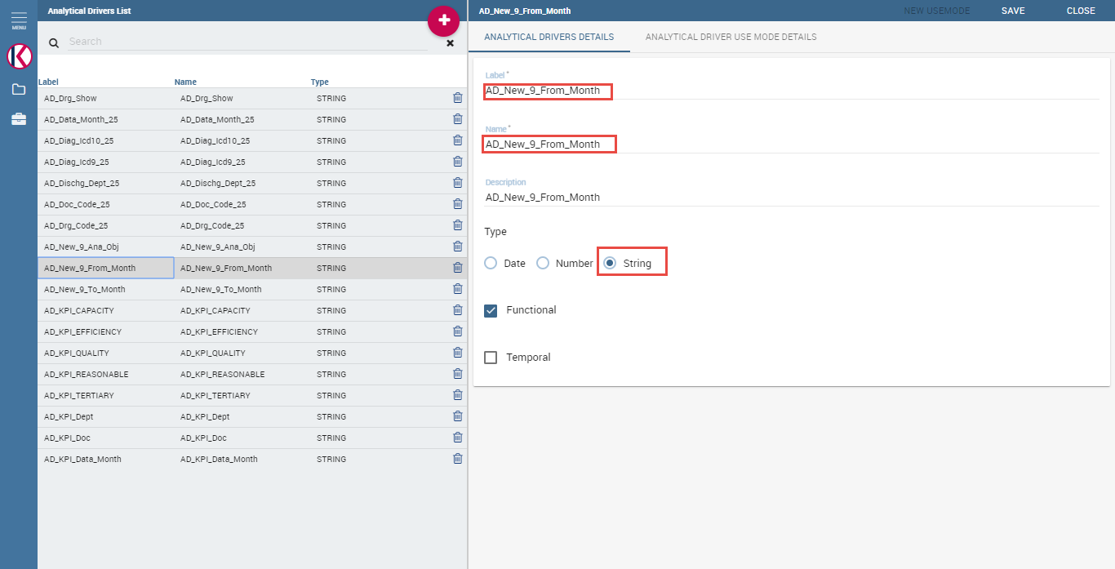

Fig.1-9 Create analytical driver

Save it then ‘ANALYTICAL DRIVER USE MODE DETAILS’ will be activated.

Press it and press ‘NEW USEMODE’ button on the right top of the screen.

Add use mode as following Fig.1-10.

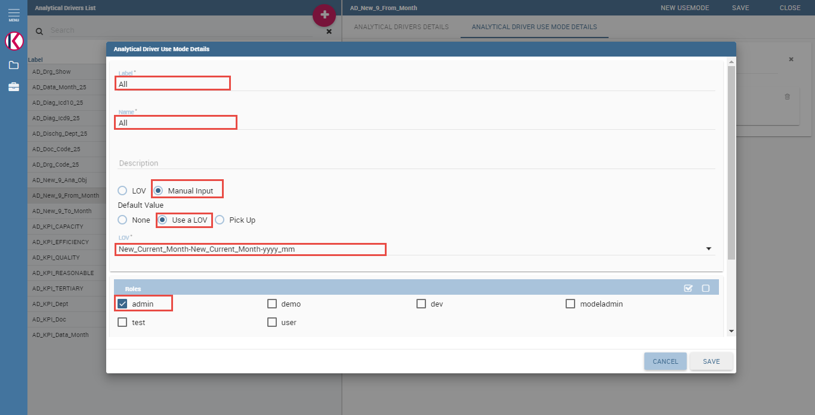

Fig.1-10 Add analytical driver use mode

Add analytical driver for ‘To_Month’ in the same way as the ‘From_Month’ as above.

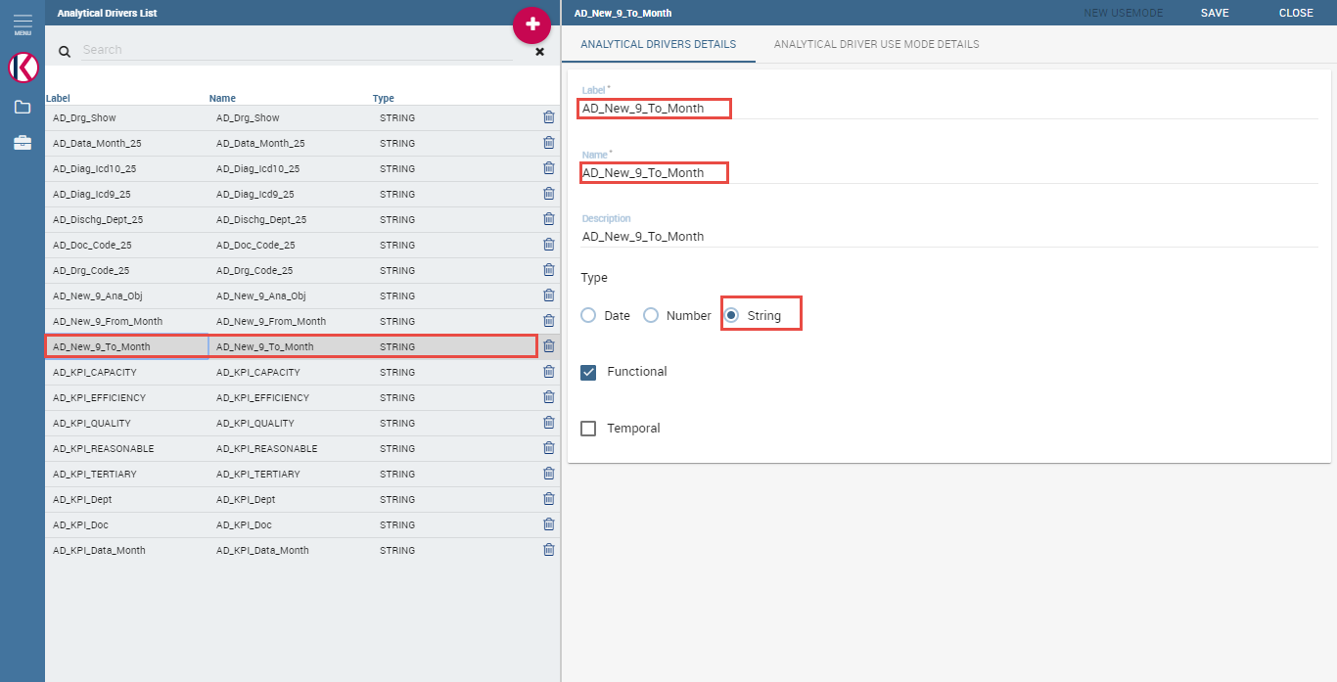

Fig.1-11 Analytical driver for ‘To_Month’

Add analytical driver for statistic type.

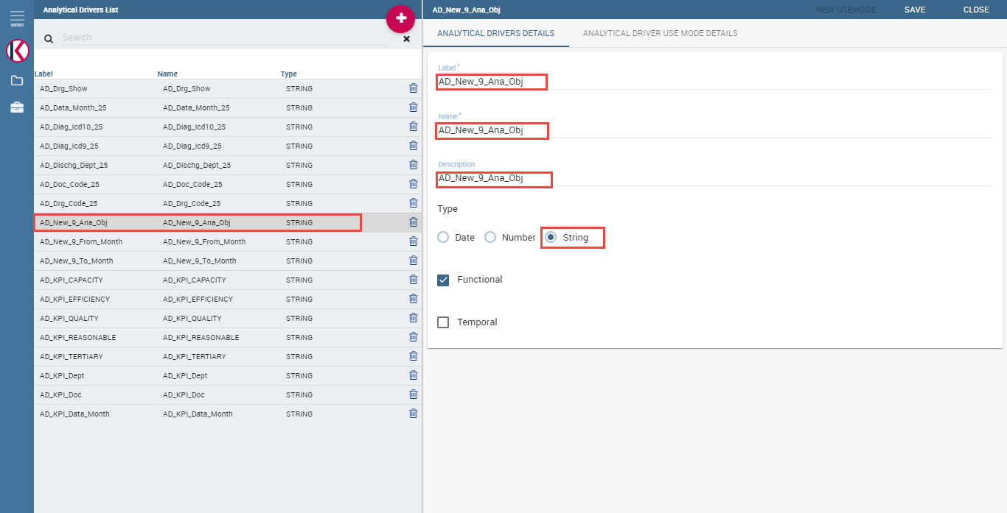

Fig.1-12 Analytical driver for statistic type

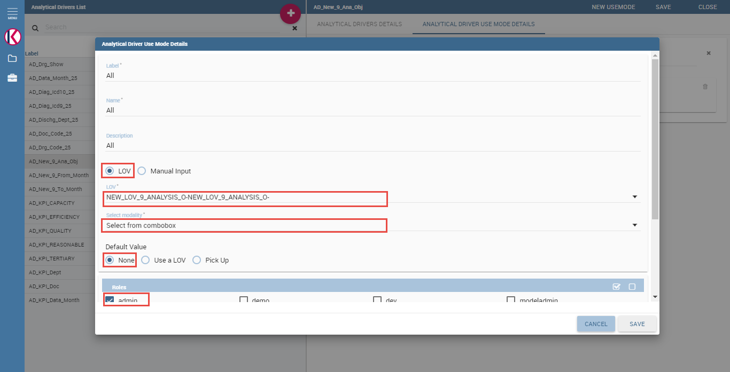

Fig.1-13 Add use mode for analytical driver of statistic type

- Create document

Create a cockpit document for FACT and BENCH.

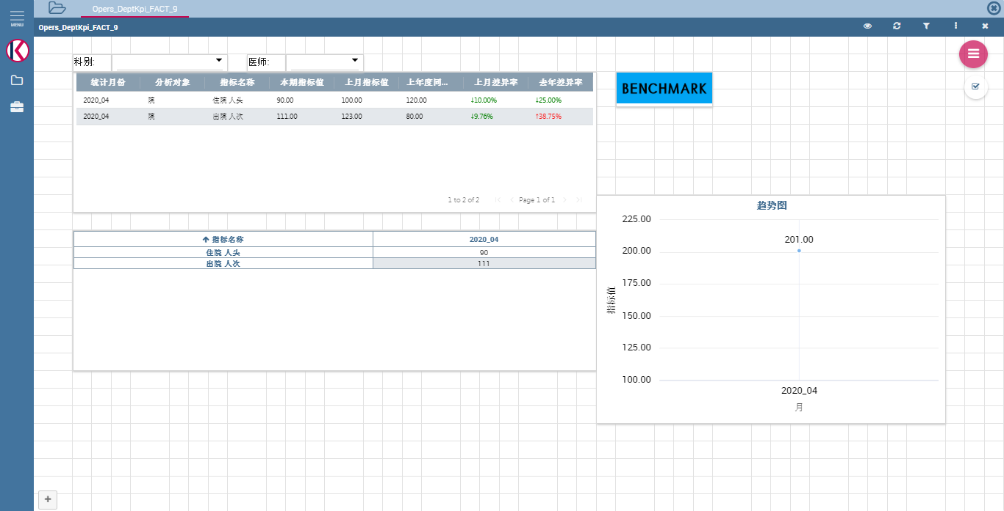

Fig.1-14 Create tables and chart, ‘BENCHMARK’ image button for cross navigation with the dataset for FACT

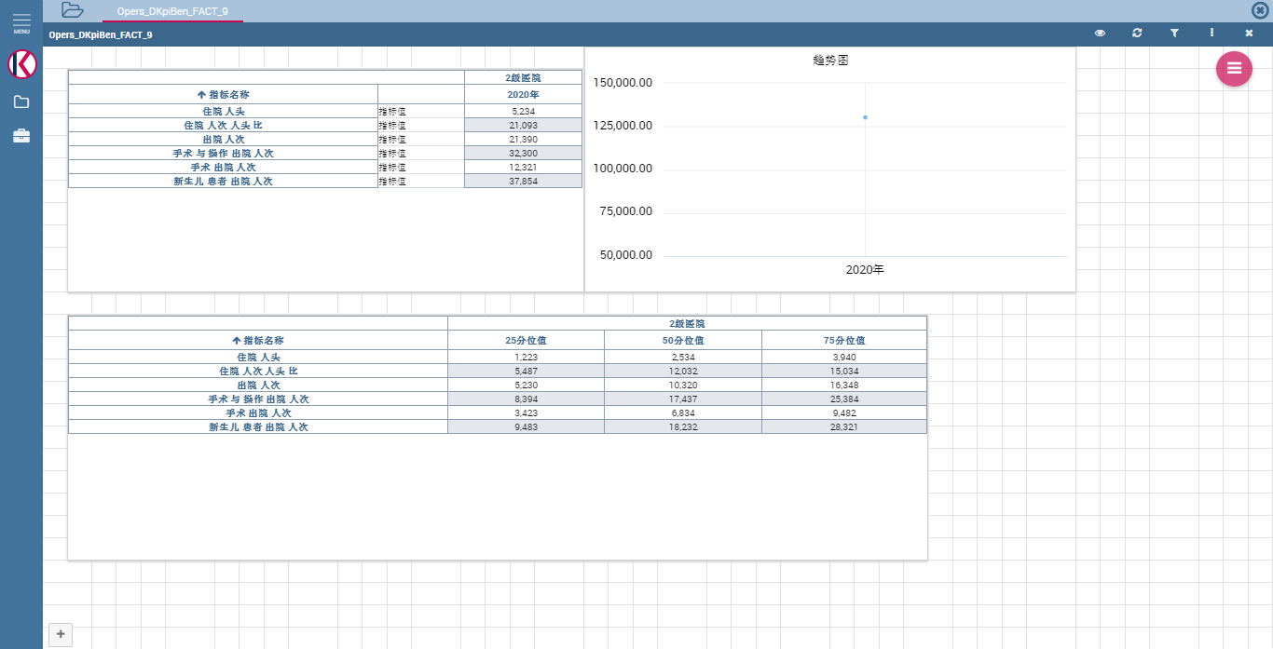

Fig.1-15 Create tables and chart with the dataset for BENCH

Set input parameters for above 2 documents.

In ‘Document browser’, edit the document.

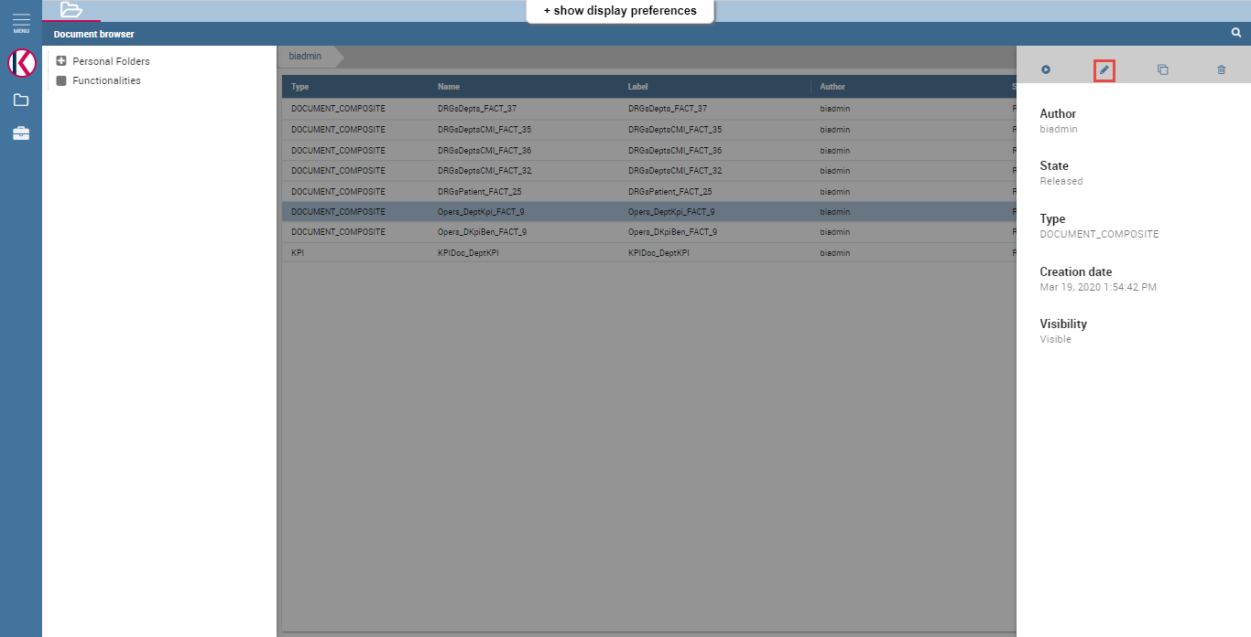

Fig.1-16 Edit document

Link 3 analytical drivers(‘From_Month’, ‘To_Month’, ‘Statistic Type’) to FACT document as following Fig.1-17.

Link 2 analytical drivers(‘From_Month’, ‘To_Month’) to BENCH document as following Fig.1-18.

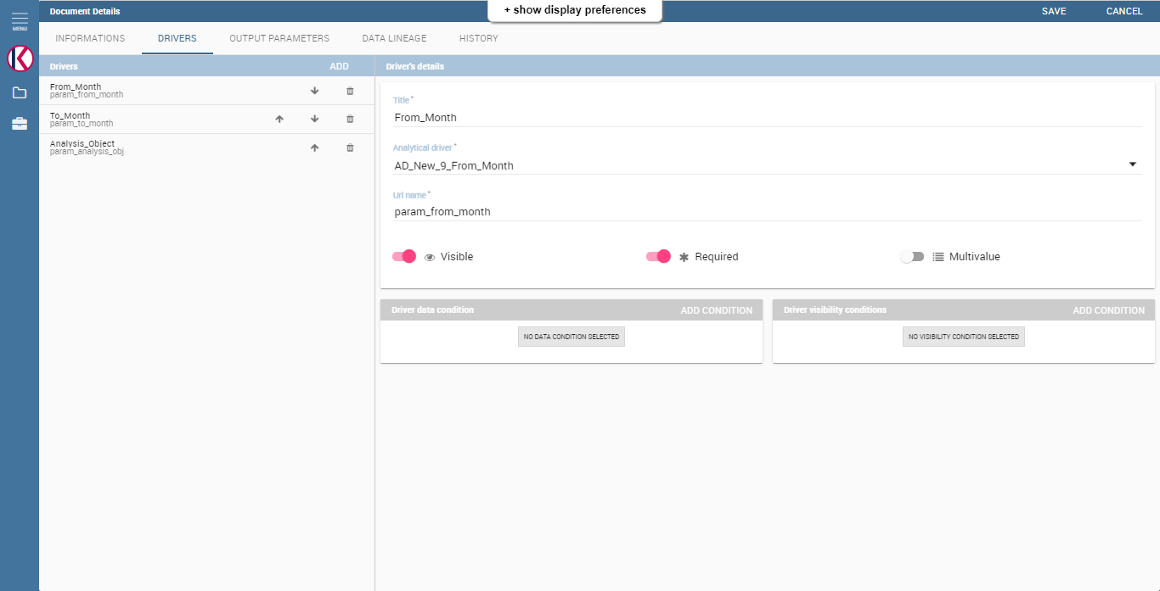

Fig.1-17 Link analytical driver to FACT document

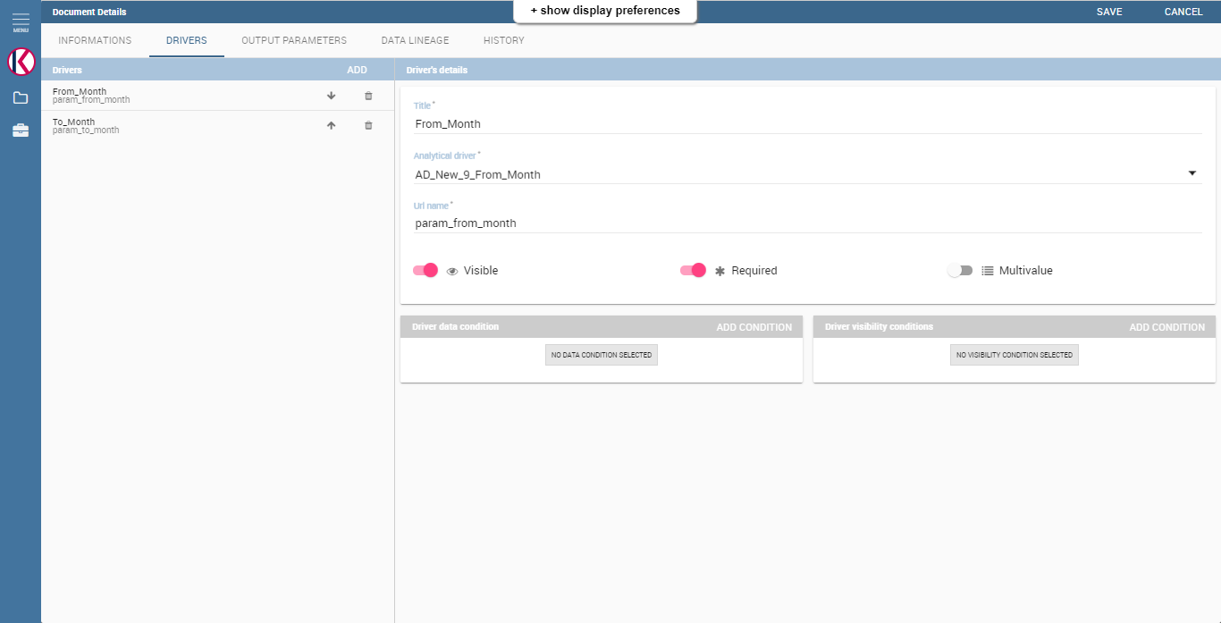

Fig.1-18 Link analytical driver to BENCH document

Create cross navigation between FACT document and BENCH document.

Choose ‘Cross Navigation Definition’ first.

Create cross navigation and make links between parameters of both documents.

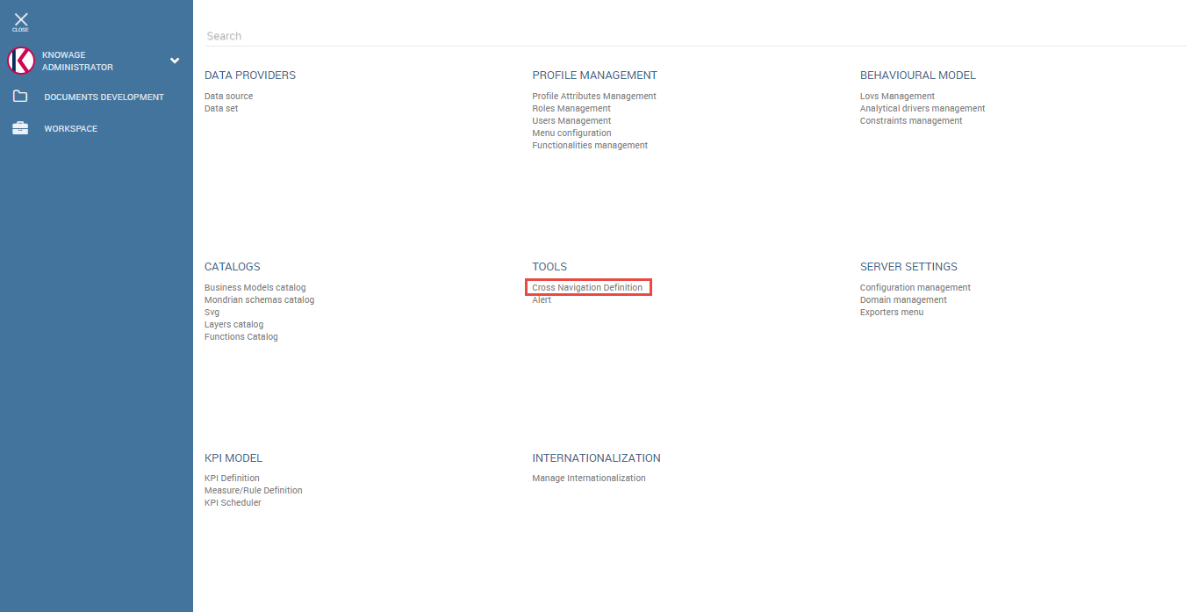

Fig.1-19 Cross navigation definition

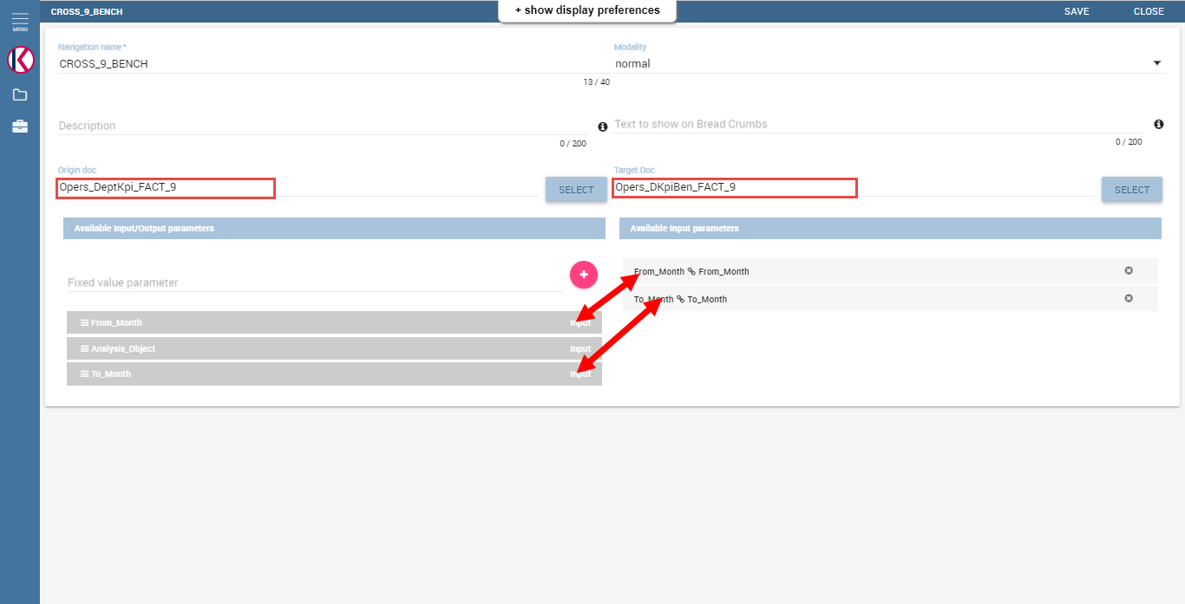

Fig.1-19 Create cross navigation and link between input parameters

Customize data configuration on document as following Fig.1-20.

Make relationships between the parameters of document and parameters of the dataset as following Fig.1-21.

Set cross navigation to ‘BENCHMARK’ image button as following Fig.1-22.

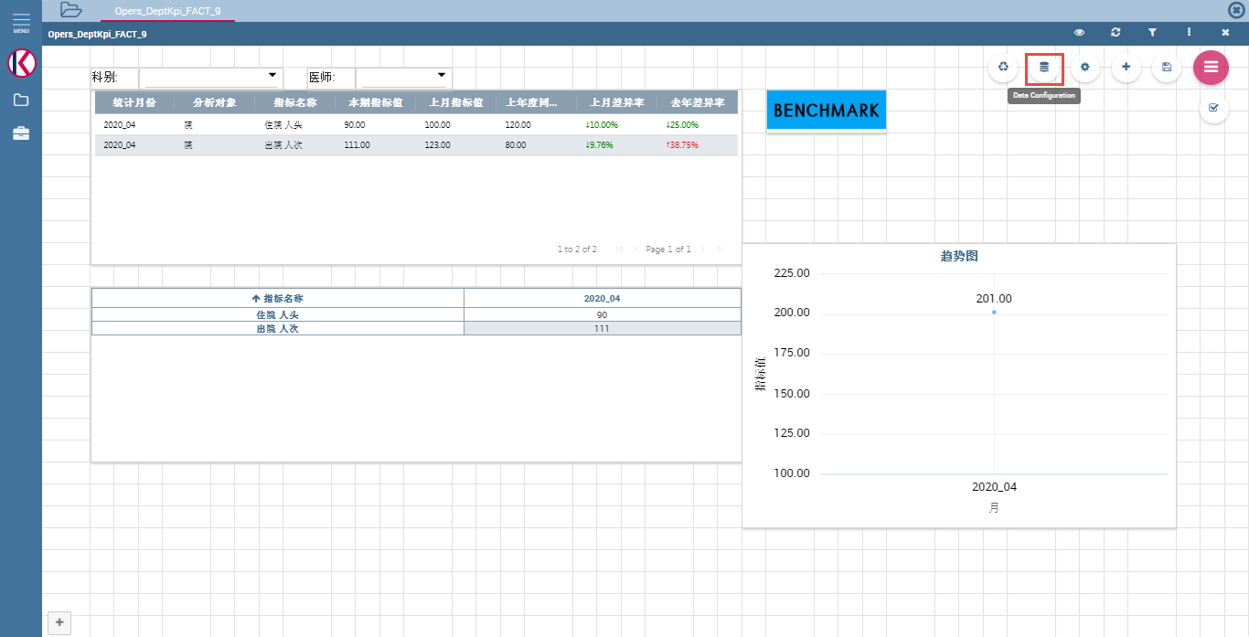

Fig.1-20 Choose data configuration

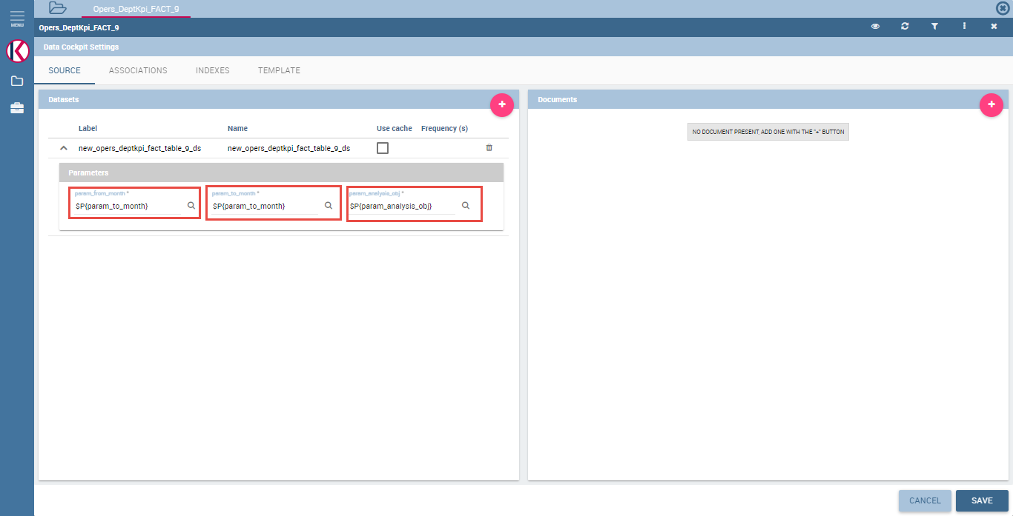

Fig.1-21 Relationship between parameters of dataset and parameters of document

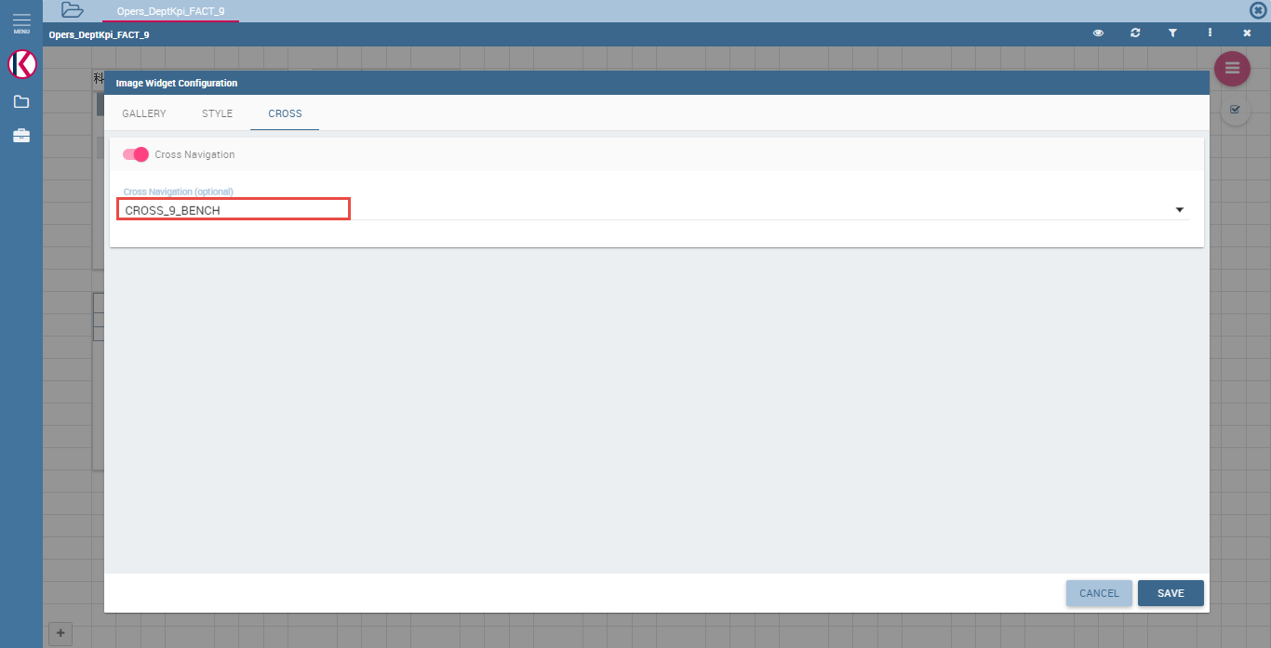

Fig.1-22 Set cross navigation to image button

2. KPI Document

- Create datasets with same parameters as the normal documents.

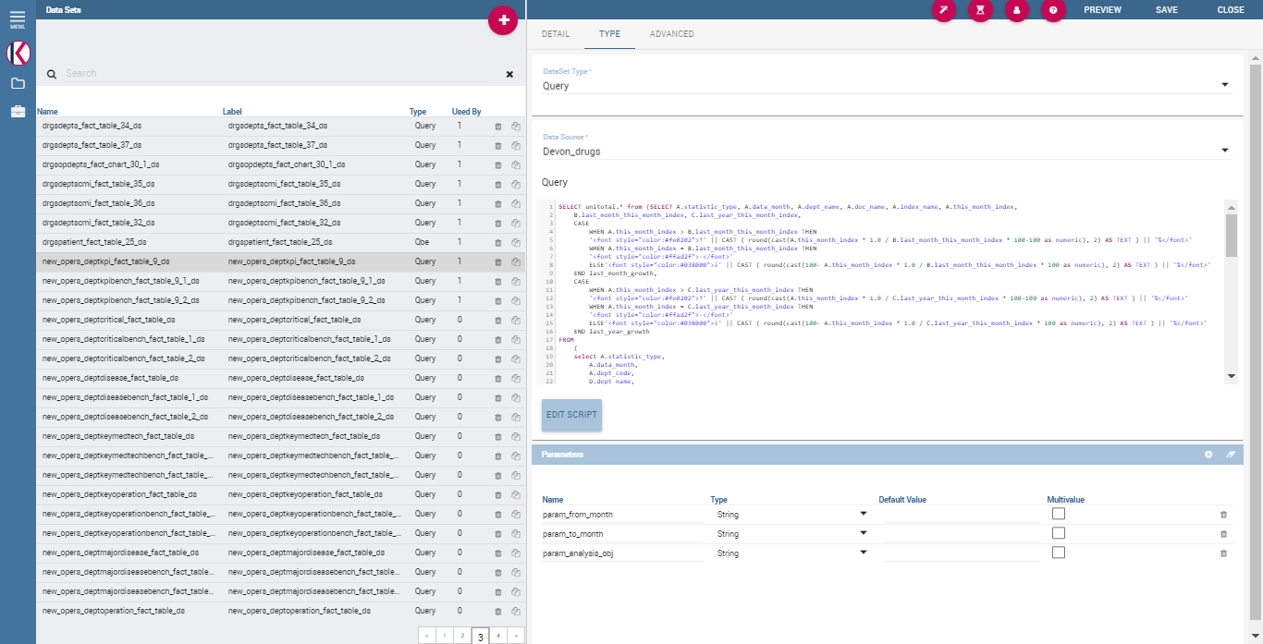

Fig.2-1 Dataset creation

- Measure/Rule Definition

Choose Measure/Rule definition.

Create measures for ‘医疗服务能力’, ‘医疗服务质量’, ‘医疗服务效率’, ‘合理用药’, ‘三级医院绩效考核’ as following Fig.2-4.

In this case, please make differences between 5 measures for the fields ‘index_code’ and ‘this_month_index’ with name.

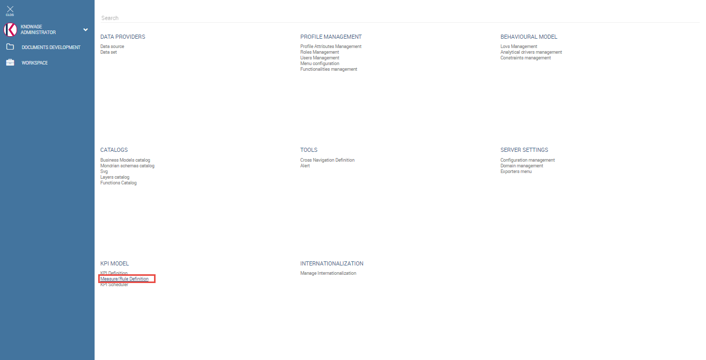

Fig.2-2 Measure/Rule Definition

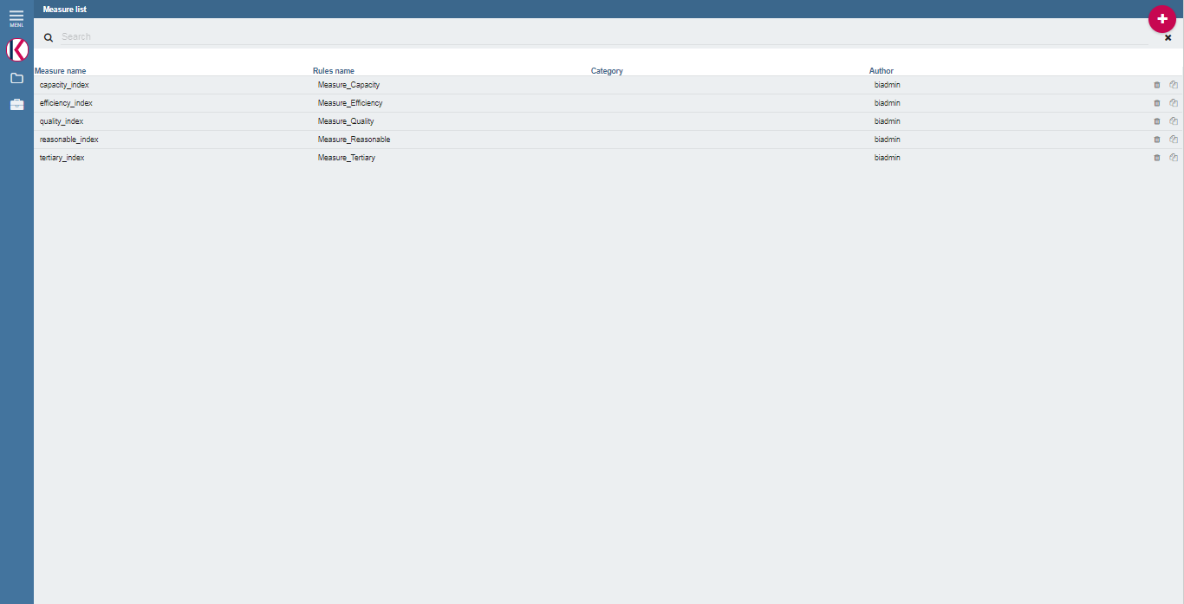

Fig.2-3 Measures list

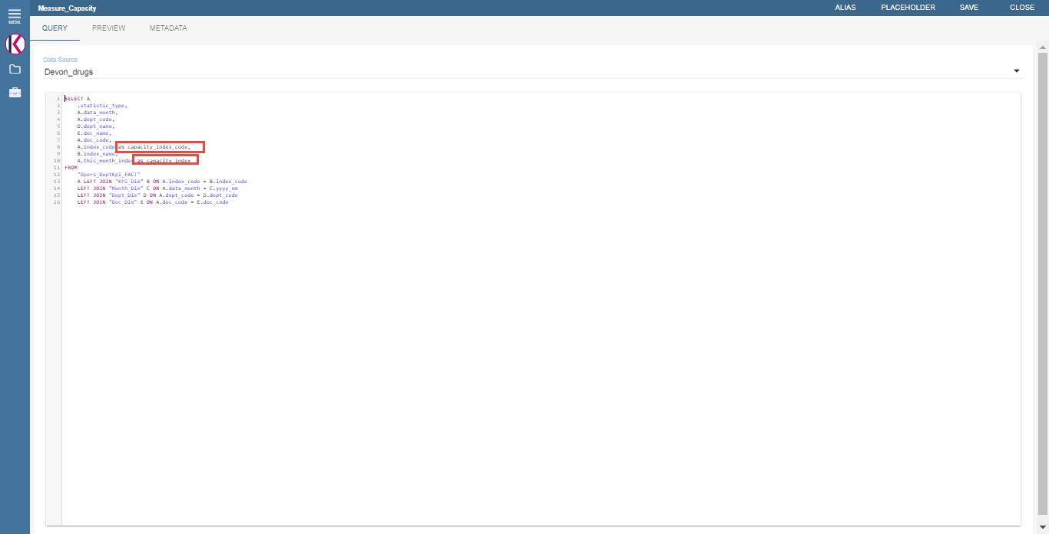

Fig.2-4 Create measure

- KPI Definition

Choose ‘KPI Definition’.

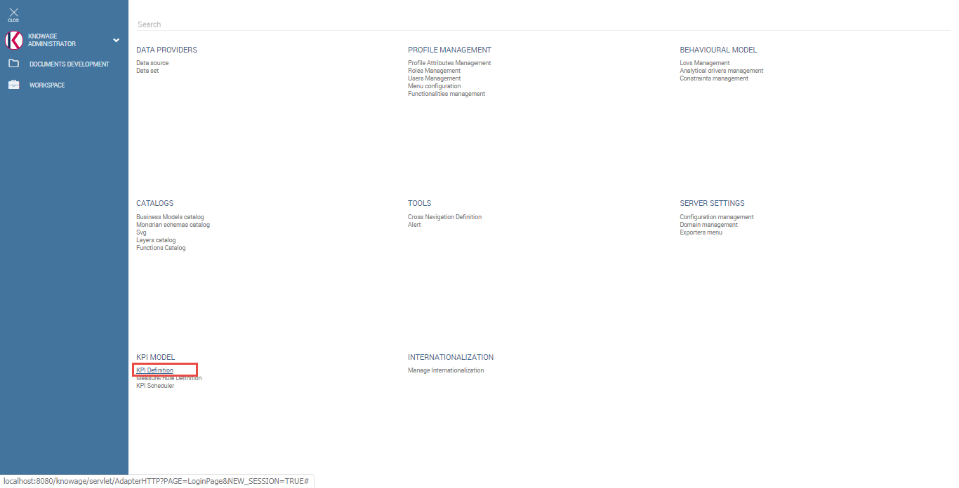

Fig.2-5 KPI Definition

Define the formula as following Fig.2-6.

Set cardinalities to make relationships with the input parameters of the document as following Fig.2-7.

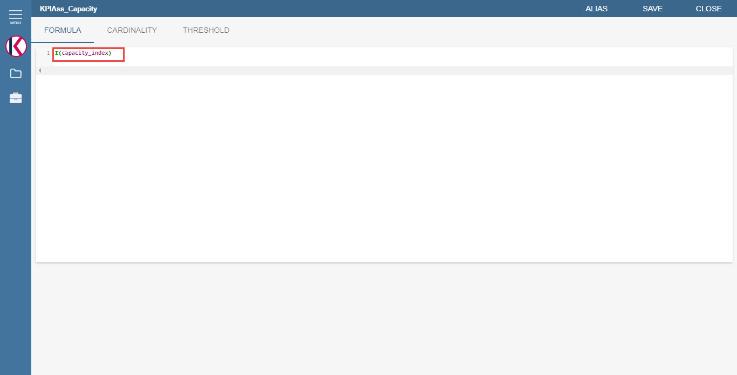

Fig.2-6 Formula for KPI

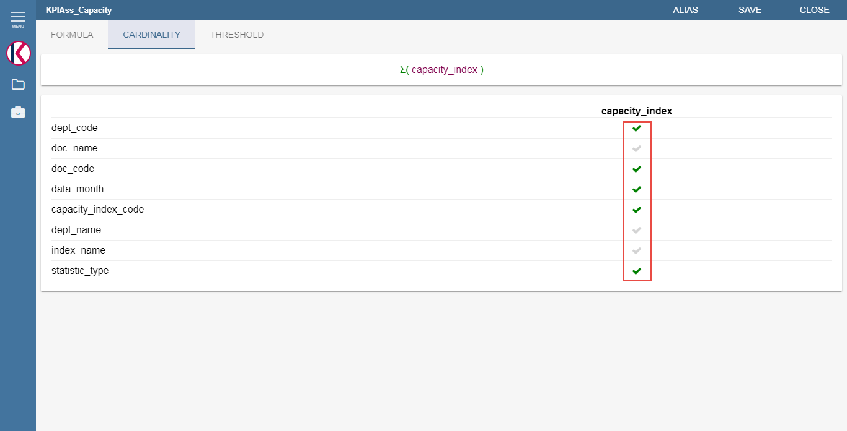

Fig.2-7 Cardinality

Create threshold for KPI as following Fig.2-8 and save all KPI settings.

Create KPIs for ‘医疗服务能力’, ‘医疗服务质量’, ‘医疗服务效率’, ‘合理用药’, ‘三级医院绩效考核’ as following Fig.2-9 too.

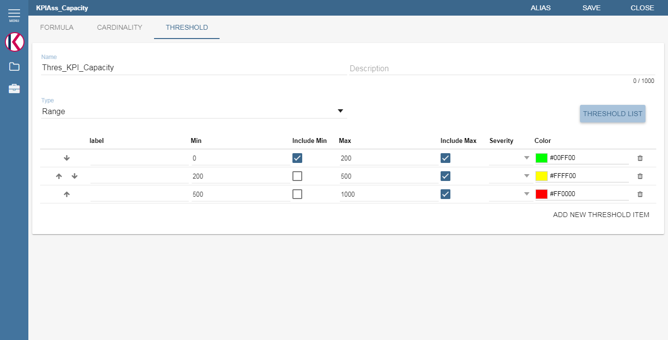

Fig.2-8 Threshold

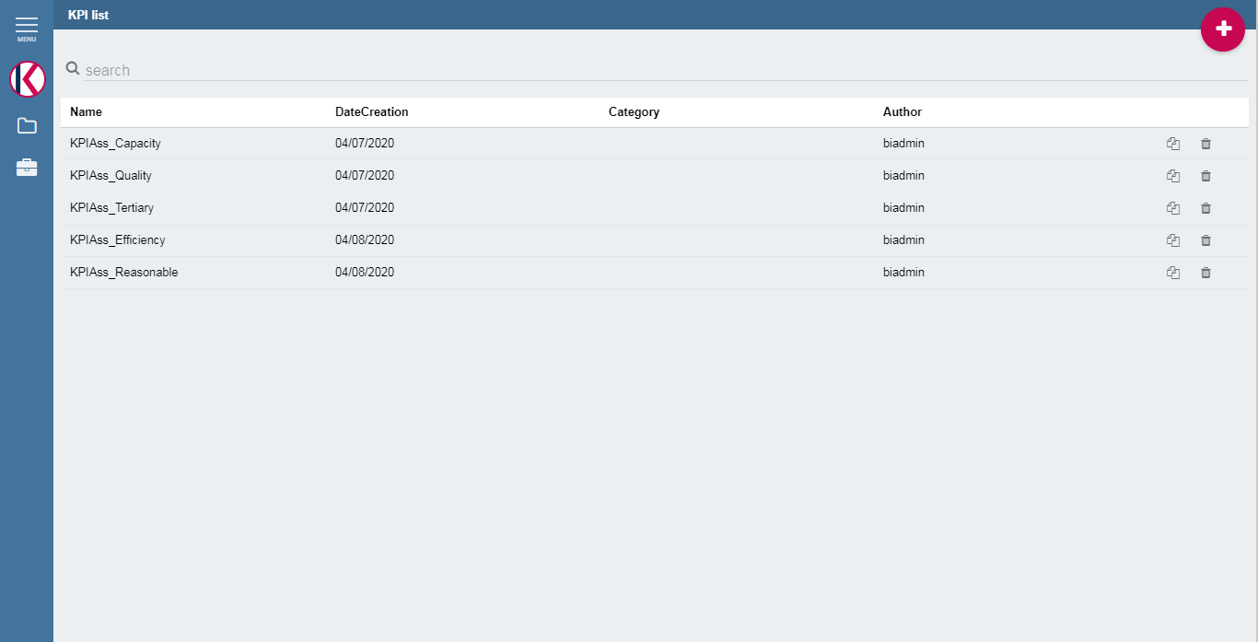

Fig.2-9 KPI list

- KPI scheduler

Choose ‘KPI Scheduler’.

Select all KPI associations for 5 categories as following Fig.2-11.

Choose frequency as following Fig.2-12.

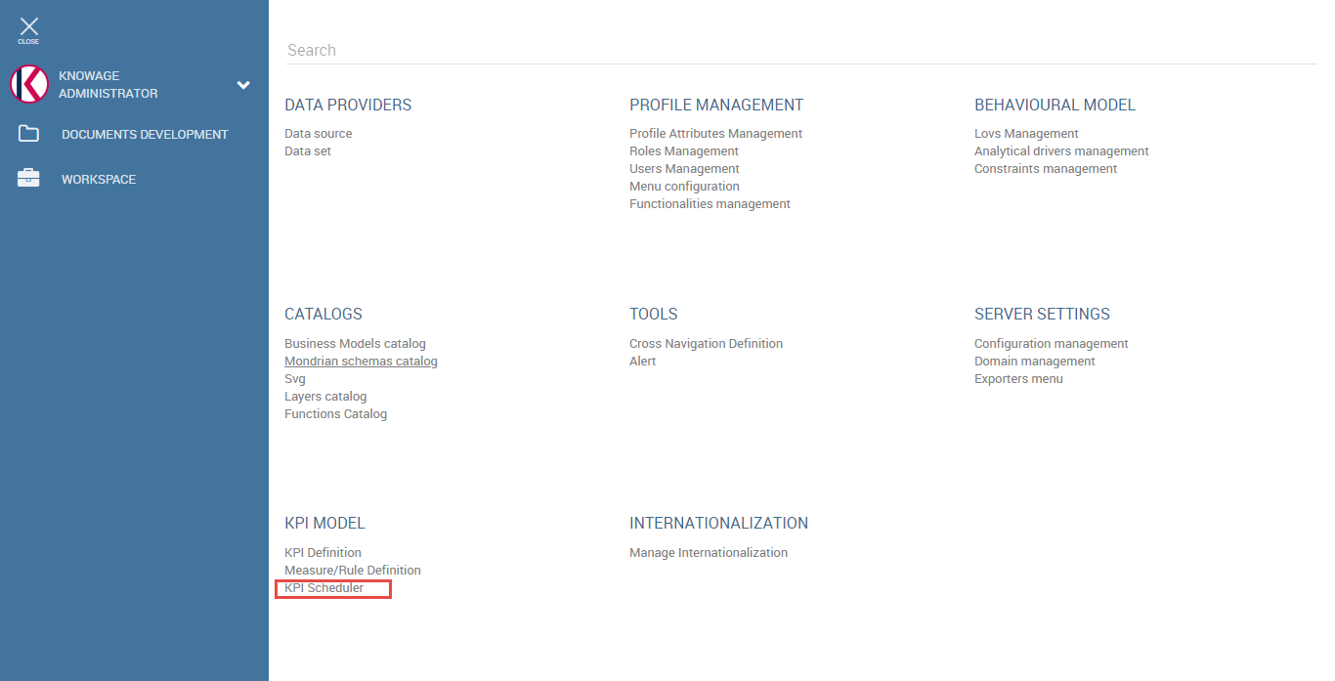

Fig.2-10 KPI Scheduler

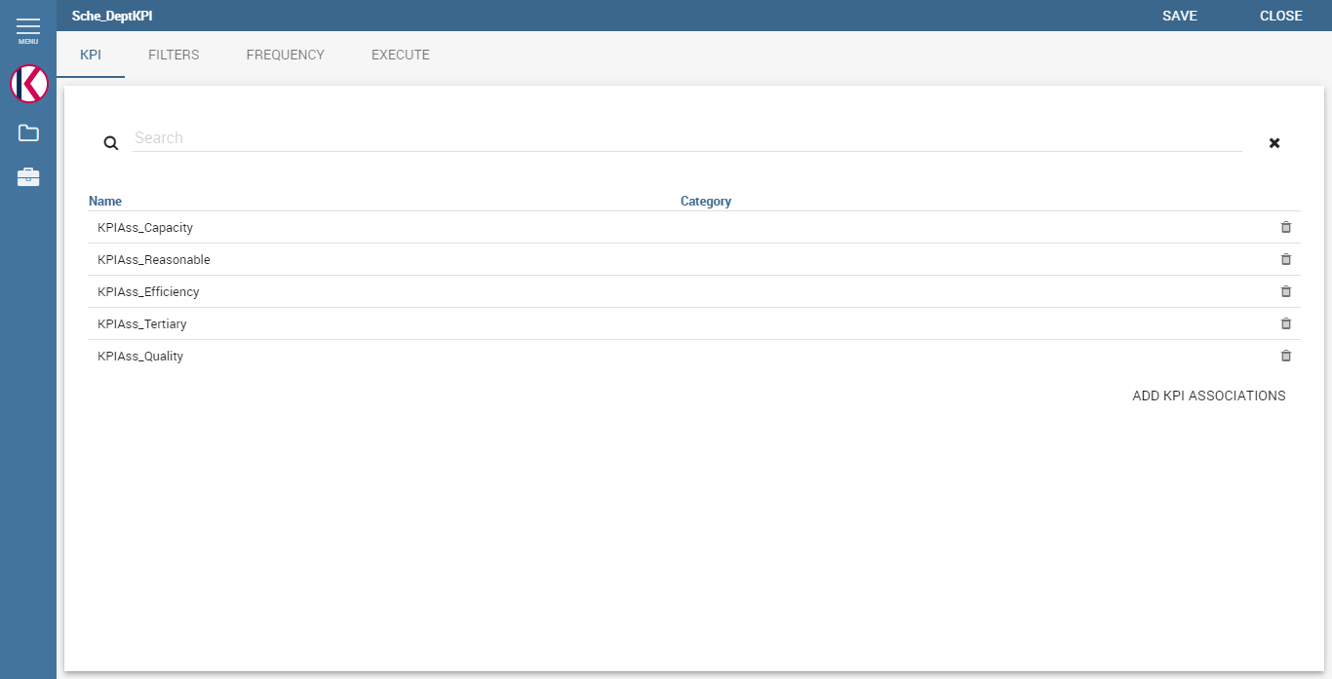

Fig.2-11 Add KPI associations

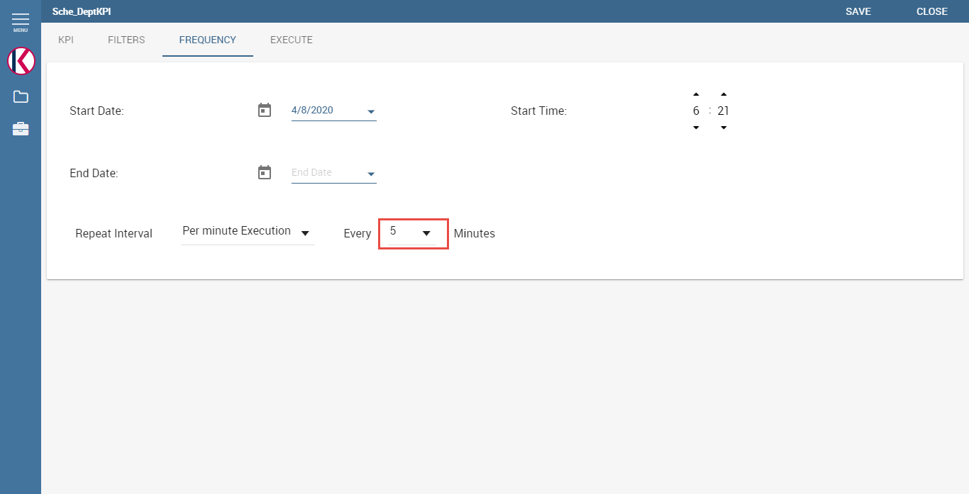

Fig.2-12 Scheduler Frequency

- Create KPI document

Create KPI document as following Fig.2-13.

You can choose document type(List, Widget) and view type(Speedometer, KPI Card).

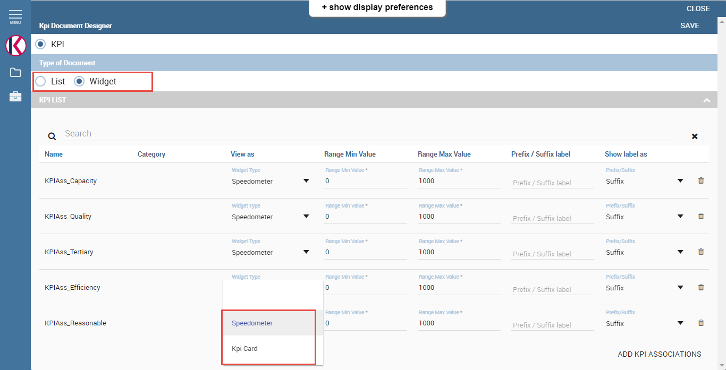

Fig.2-13 KPI document

- Create lovs and analytical drivers for KPI document

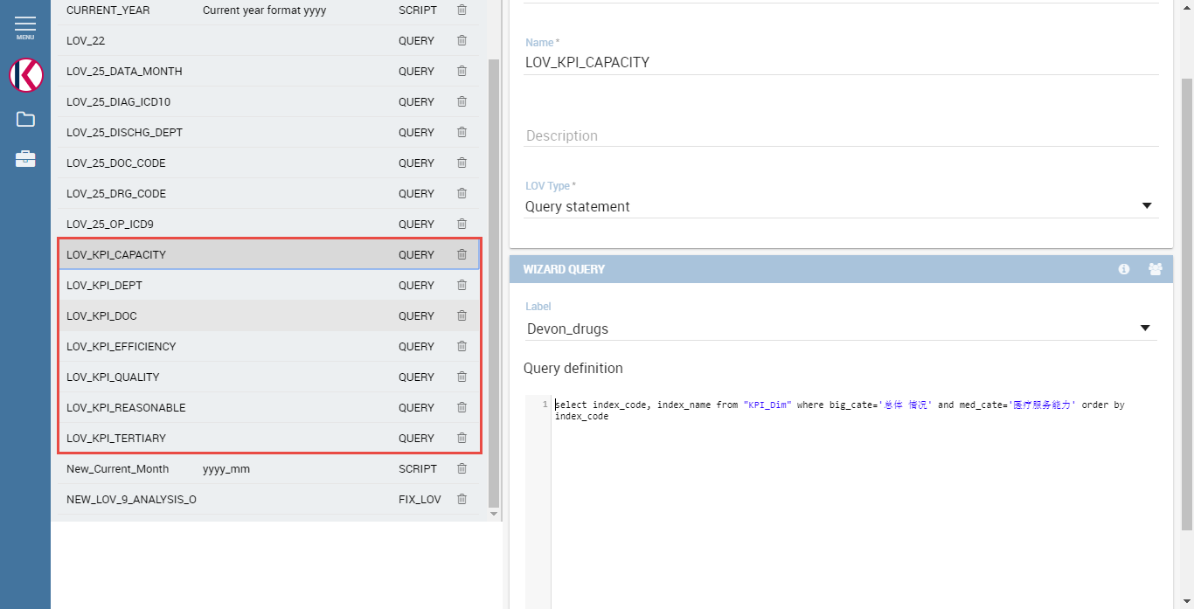

Fig.2-14 LOVs for KPI document

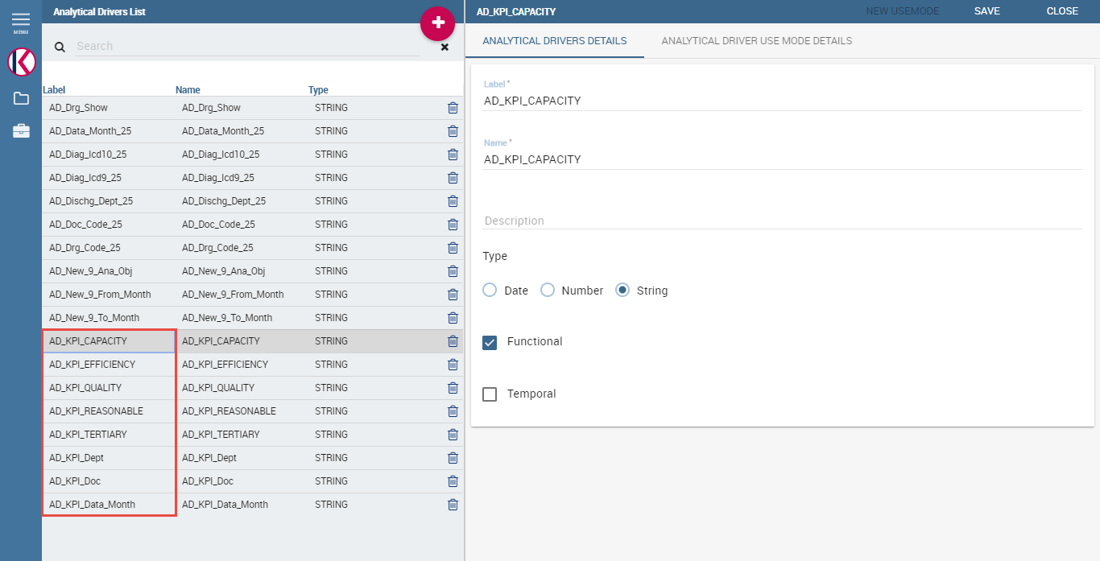

Fig.2-15 Analytical drivers for KPI document

- Add analytical drivers as input parameters to KPI document

Url name should be same as the cardinality value of the KPI.

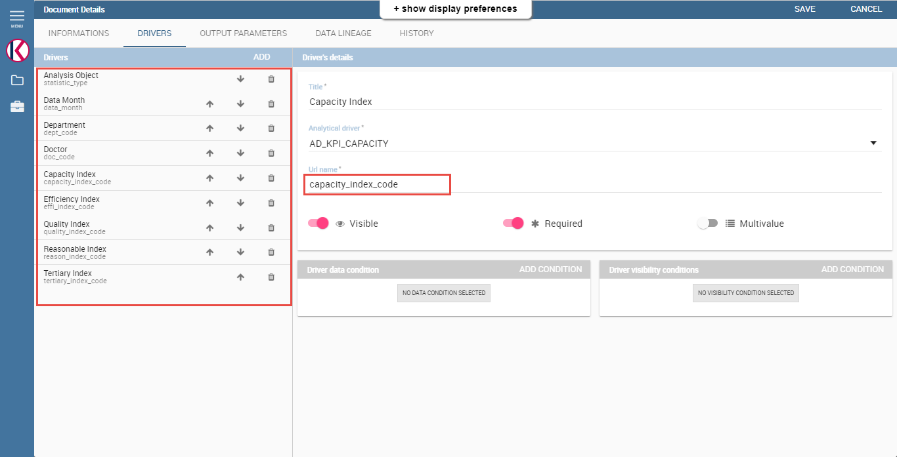

Fig.2-16 Add analytical drivers to KPI document

3. Patient Document

- Create Dataset

Select ‘Data set’ as following Fig.1-1.



Fig.3-1 Select dataset

Create dataset as following Fig.3-2.

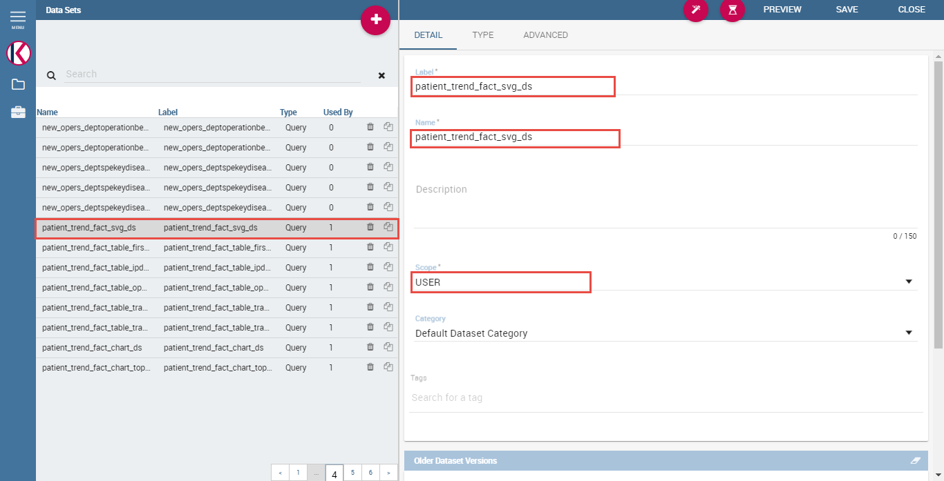

Fig.3-2 Create dataset

Select dataset type as ‘Query’ and data source and input query as following Fig.3-3.

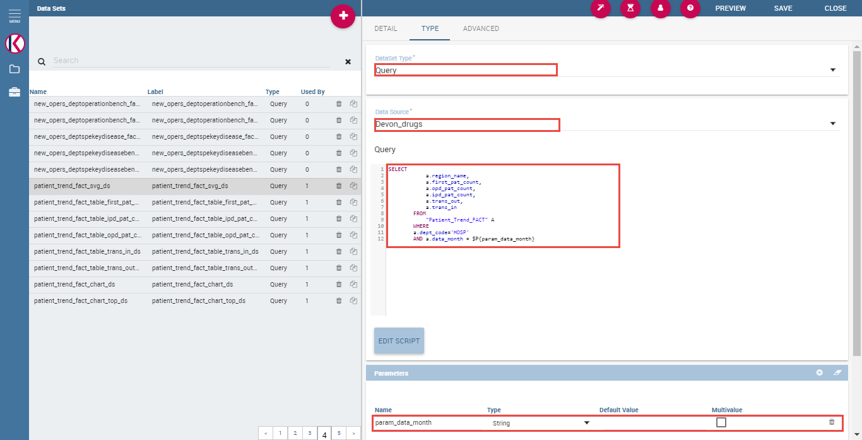

Fig.3-3 Customize dataset

Add parameters as above Fig.3-3.

Create dataset for 5 indicators(首诊病人数, 门诊病人数, 住院病人数, 转出病人数, 转入病人数) same way as above too.

Create dataset for charts too.

- Analytical drivers management for input parameters of document

Press ‘Analytical drivers management’ as following Fig.3-4.



Fig.3-4 Analytical drivers management

Create 3 analytical drivers for document as following.

Add analytical driver for ‘From_Month’ parameter of document.

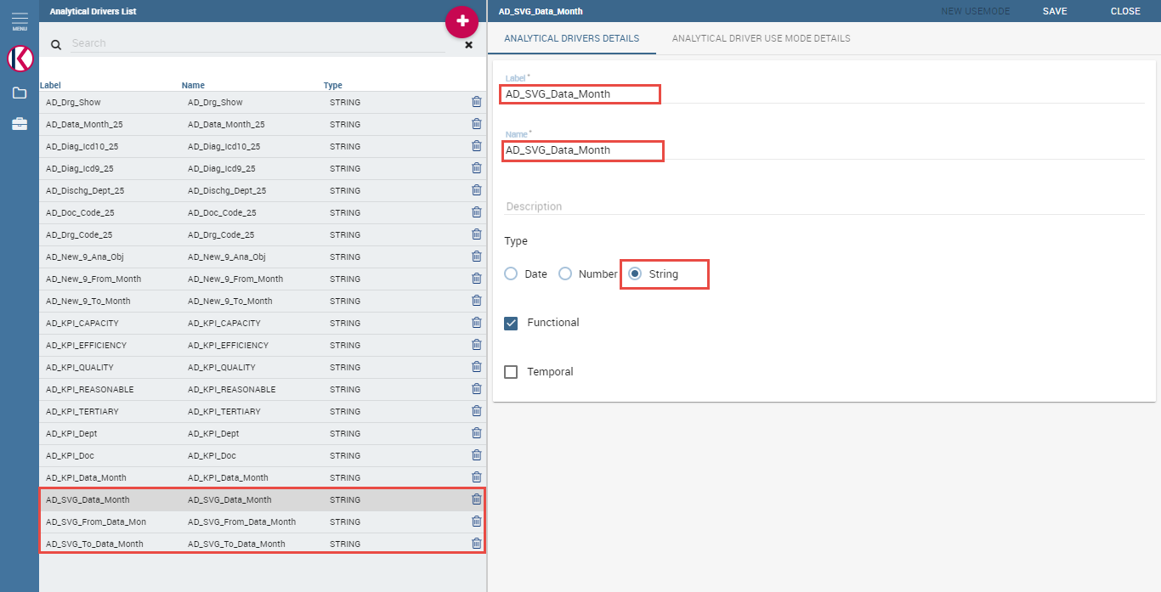

Fig.3-5 Create analytical driver

Save it then ‘ANALYTICAL DRIVER USE MODE DETAILS’ will be activated.

Press it and press ‘NEW USEMODE’ button on the right top of the screen.

Add use mode as following Fig.3-6.

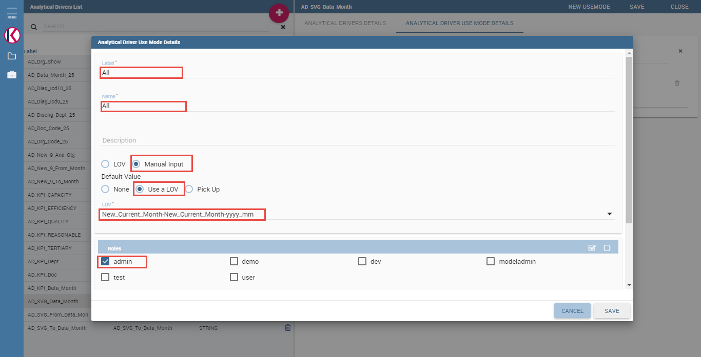

Fig.3-6 Add analytical driver use mode

- SVG Upload for SVG Viewer with China map

Select ‘SVG’ on the menu as following Fig.3-7.

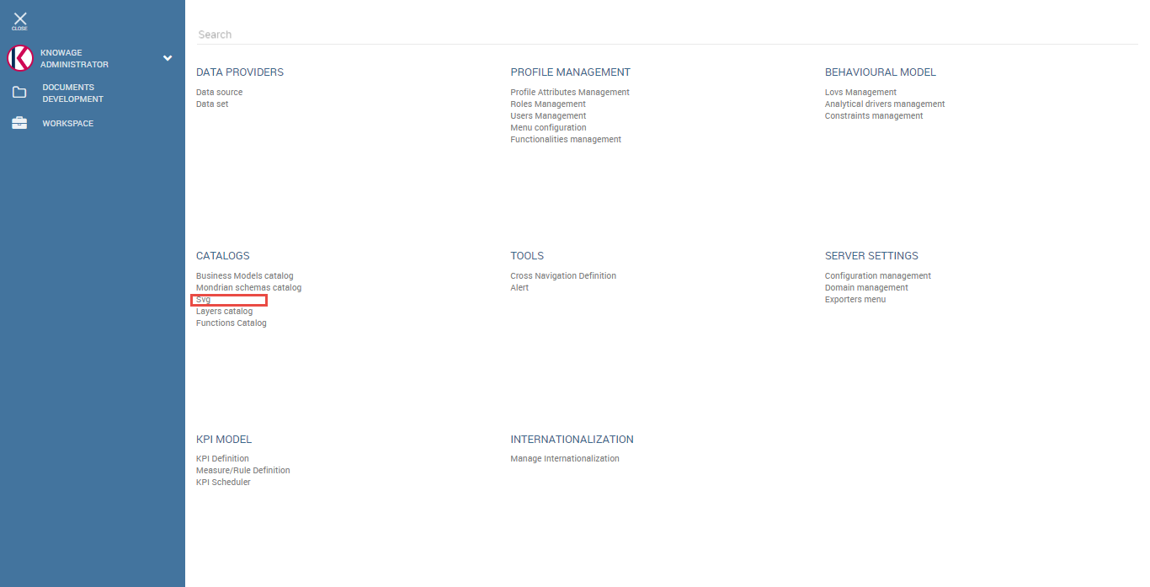

Fig.3-7 Select SVG on the menu

Click ‘Insert’ button on the top-right corner.

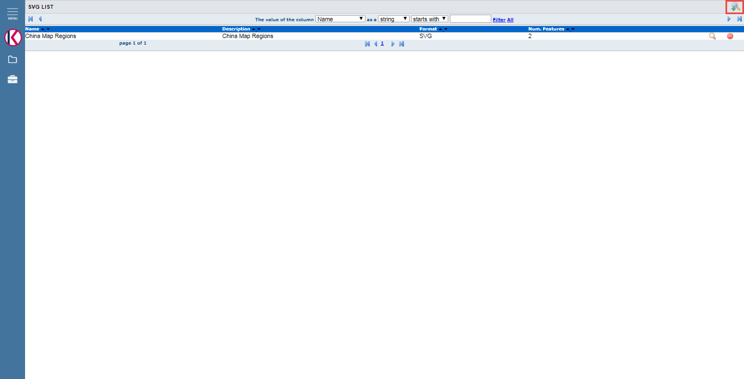

Fig.3-8 Insert SVG

Upload SVG with detailed informations as following Fig.3-9.

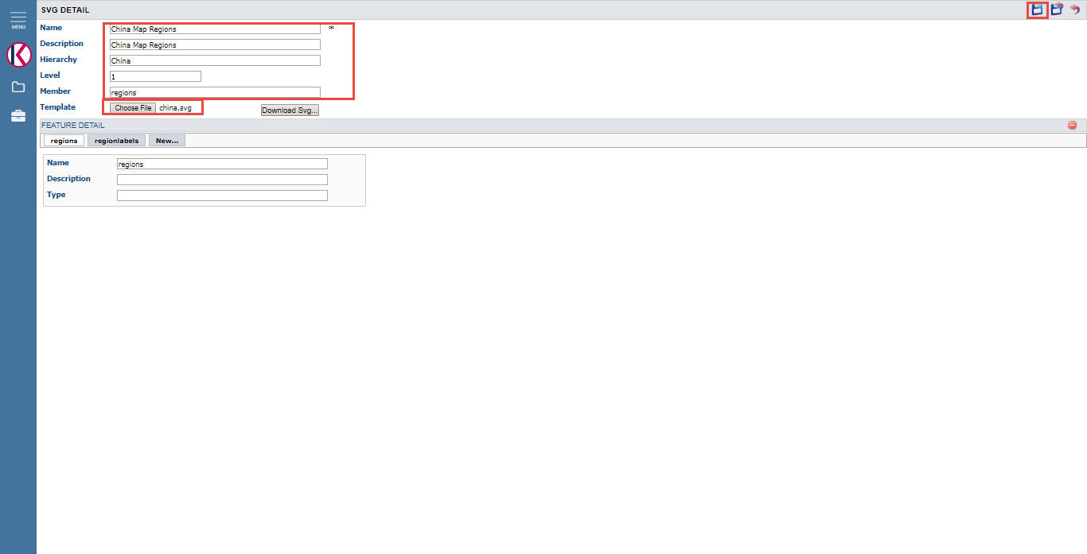

Fig.3-9 SVG upload

Name is mandatory.

Hierarchy will be used in template.xml for the SVG Viewer document.

Level starts from 1.

Member will be used in template.xml for the SVG Viewer document.

When click ‘Save’ button on the top-right corner, the features(<g> tag in the svg) will be added automatically.

Click ‘Save and Return’ button on the top-right corner.

- SVG Viewer Engine document

Add normal cockpit document as following Fig.3-10.

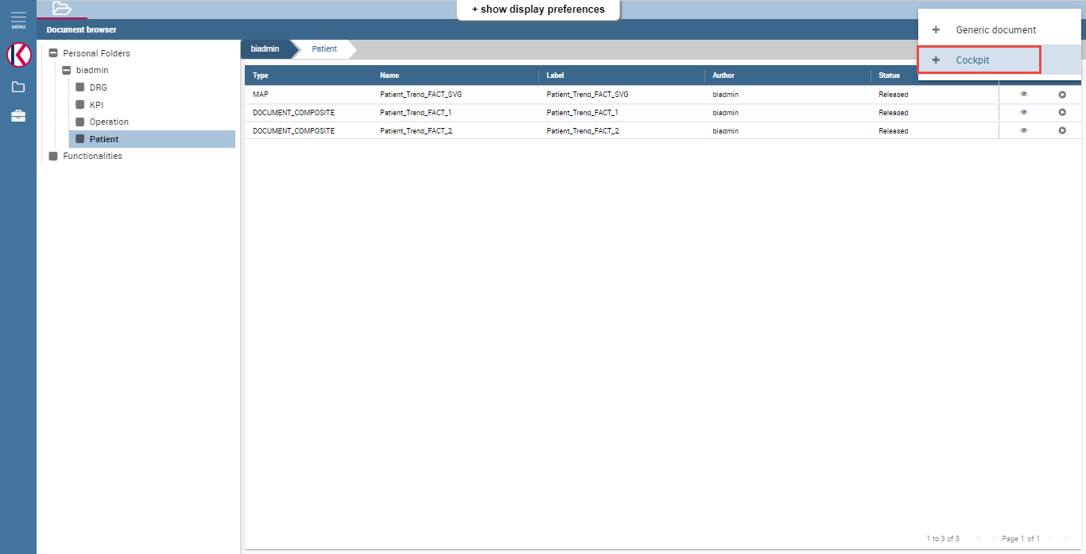

Fig.3-10 Add normal cockpit document

Save cockpit document with proper name and label as following Fig.3-11.

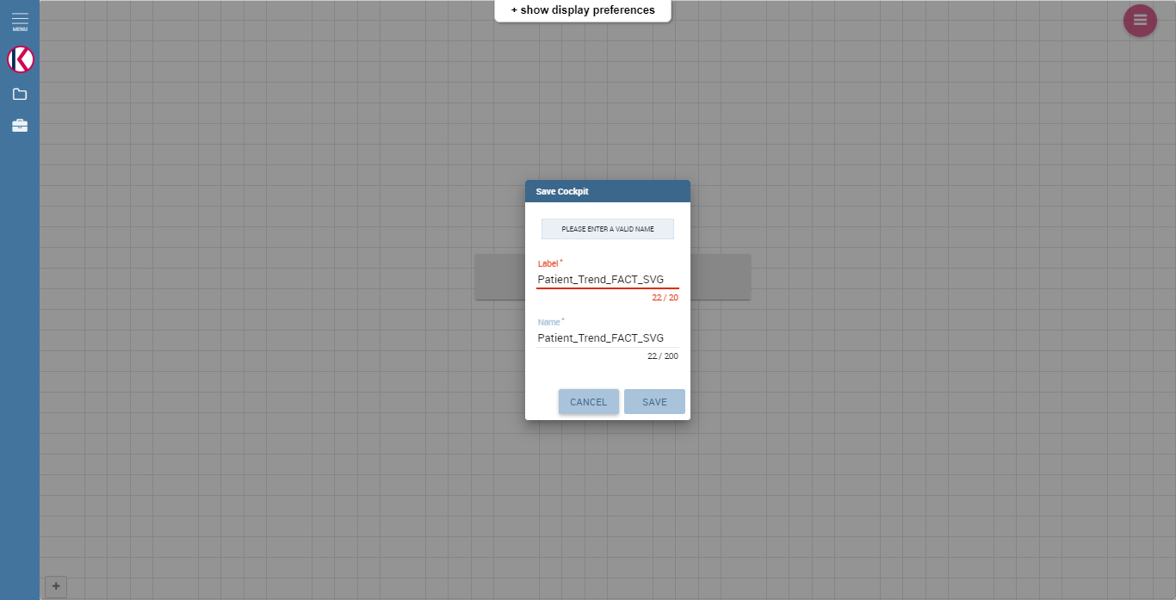

Fig.3-11 Save cockpit document

Click ‘Edit’ button to edit normal cockpit document as following Fig.3-12.

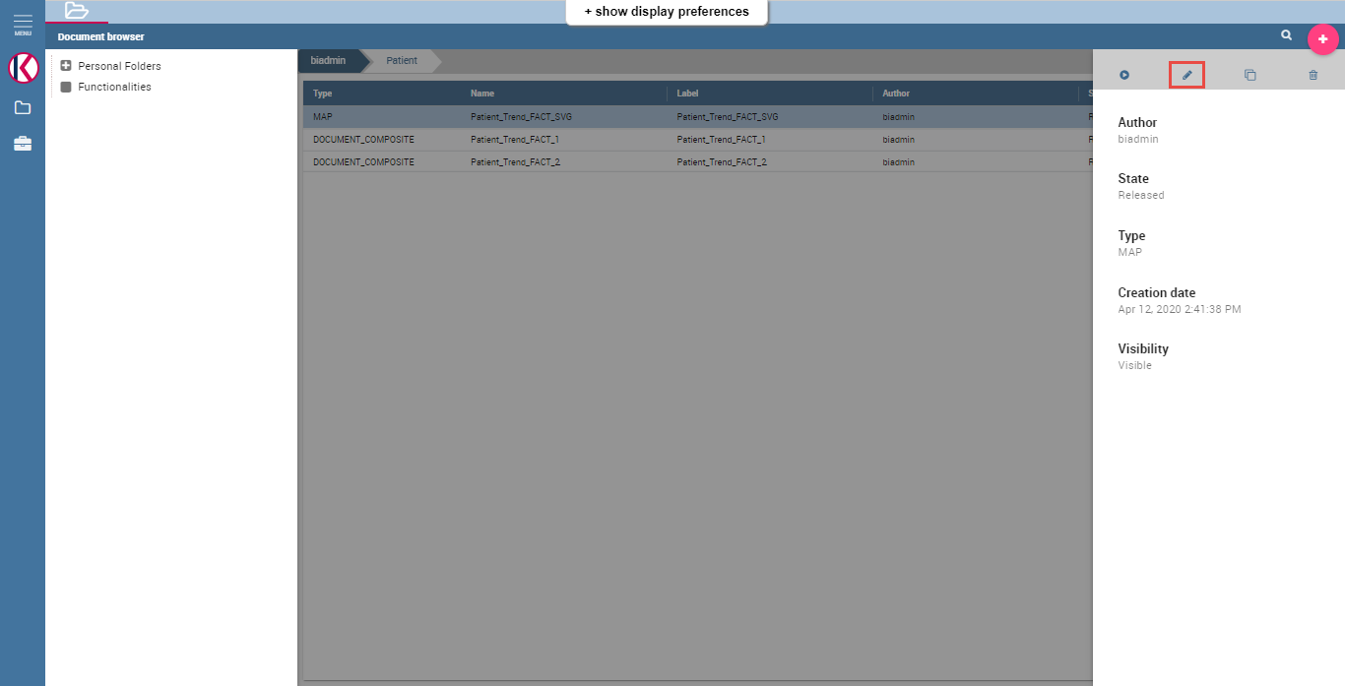

Fig.3-12 Edit cockpit document

Change document type and engine with ‘Location Intelligence’ and ‘SVG Viewer Engine’ to make the document SVG Viewer document as following Fig.3-13.

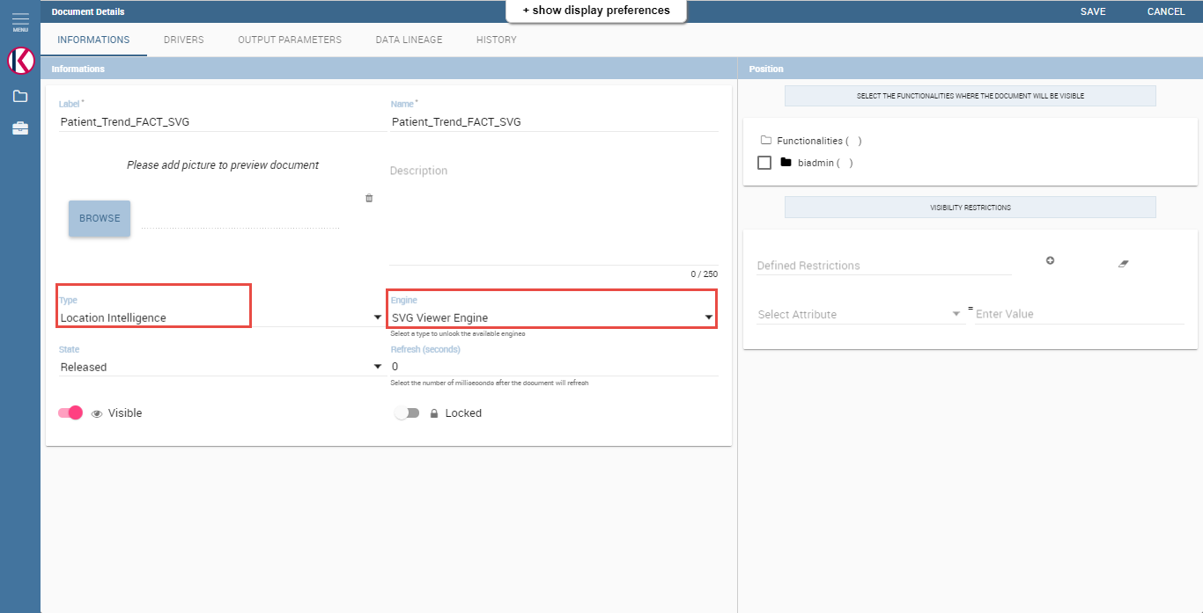

Fig.3-13 Change Type and Engine

Upload template.xml in ‘HISTORY’ tab and save it as following Fig.3-14.

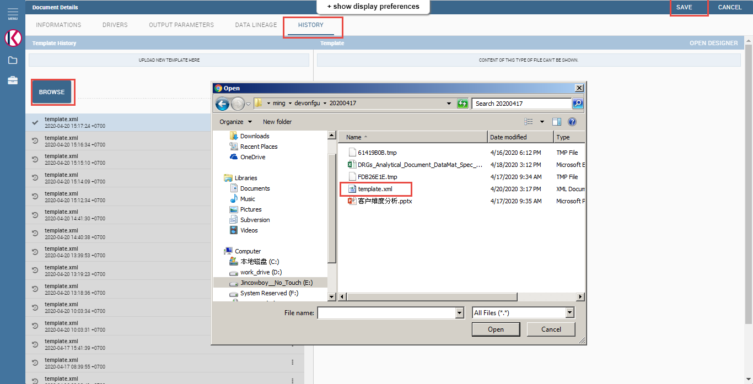

Fig.3-14 Upload template.xml

Add input parameters in ‘DRIVERS’ tag as following Fig.3-15.

Url name should be same as the name of the dataset parameter.

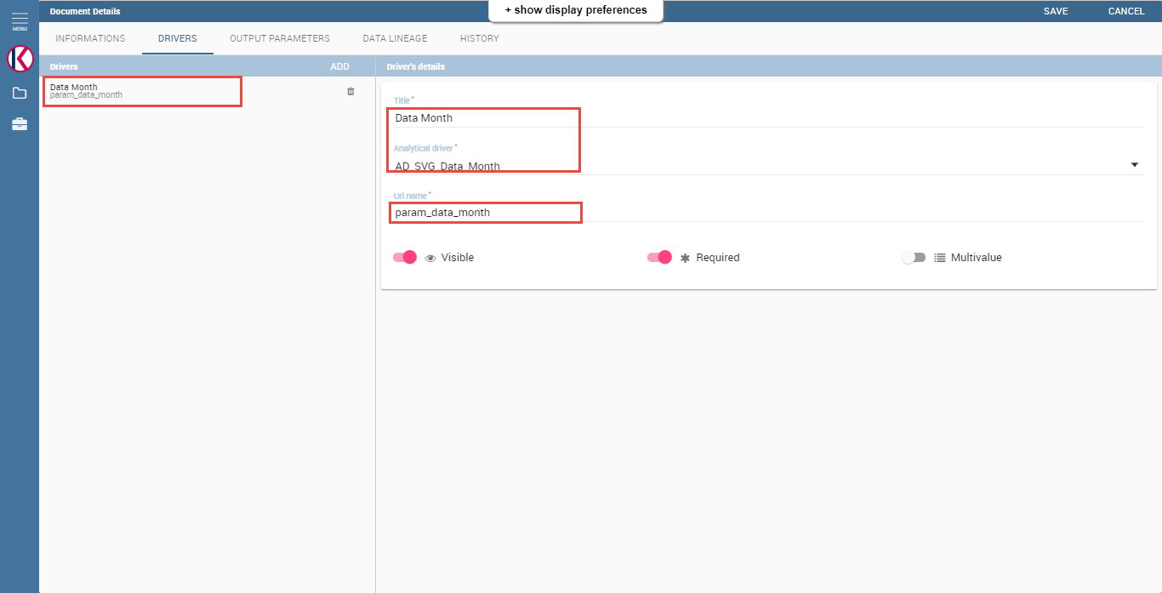

Fig.3-15 Input parameters for SVG Viewer document

- Cockpit document with svg viewer map

Add normal cockpit document and save it as Fig.3-11.

Add input parameters for ‘Data Month’, ‘From Month’ and ‘To Month’ as Fig.3-15.

Add normal cockpit document and click ‘Data Configuration’ button as following Fig.3-16.

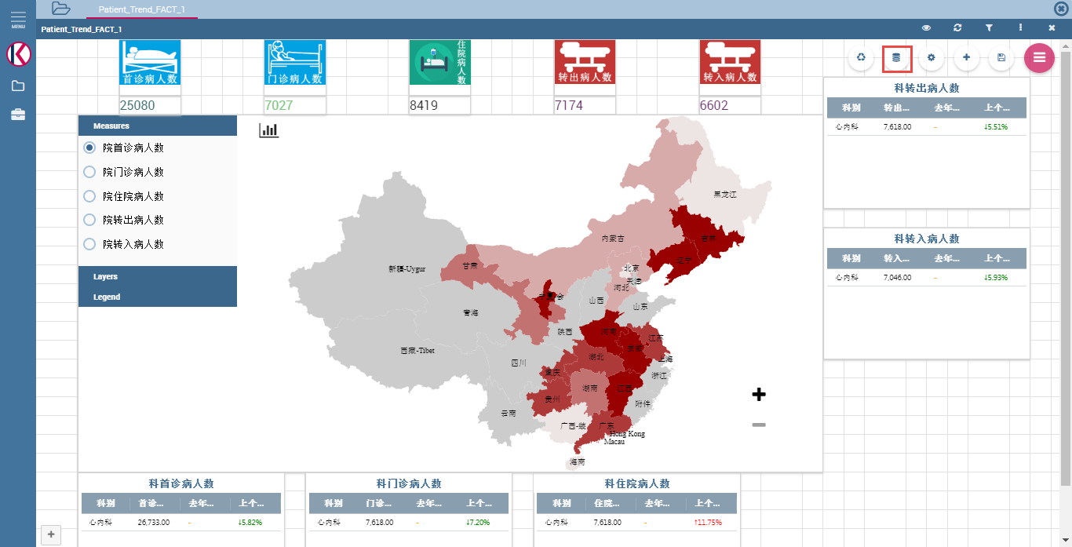

Fig.3-16 Cockpit document with map viewer

Add datasets and document and link document input parameters to dataset’s input parameter and svg viewer document’s parameter as following Fig.3-17.

Save them.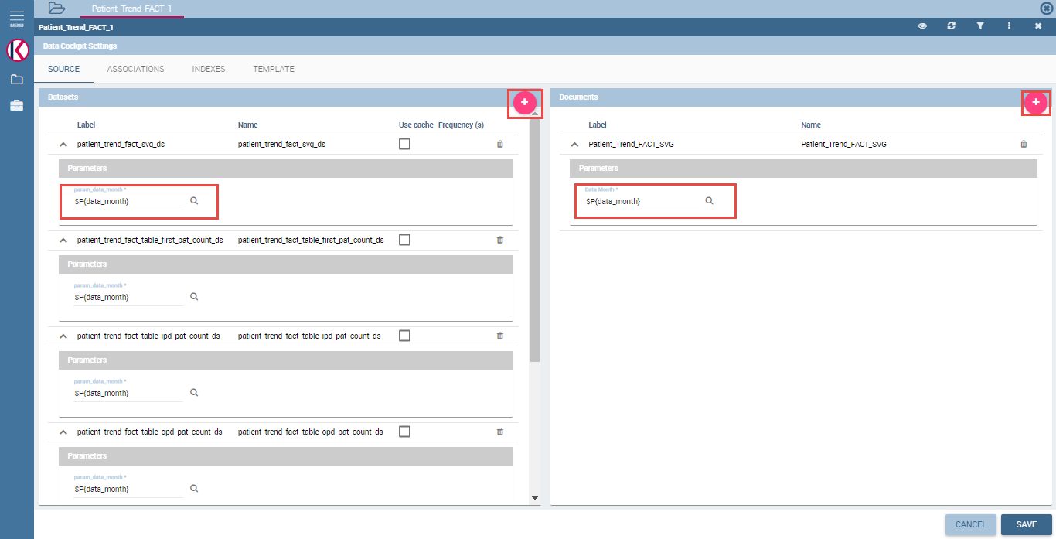

Fig.3-17 Add datasets and documents

Add document widget using ‘Add Widget’ button as following Fig.3-18.

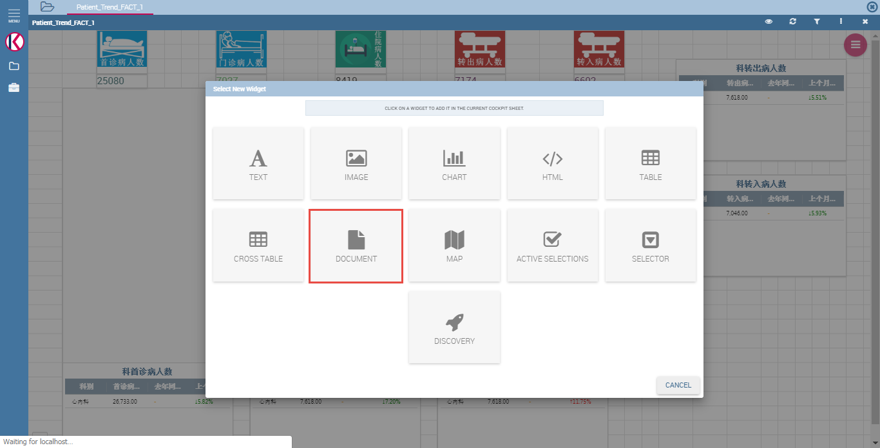

Fig.3-18 Add document widget

Select svg viewer document and save it.

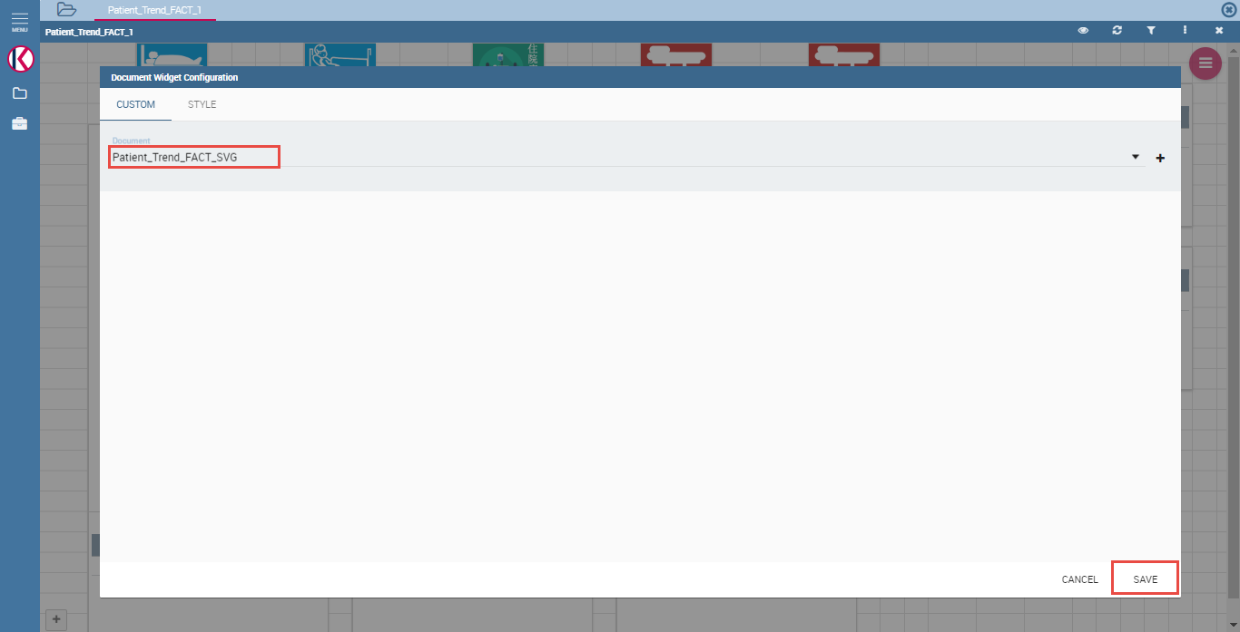

Fig.3-19 Select svg viewer document

Save cockpit document

4. Birt report and jasper report install on Knowage

※ Knowage Report Designer and Jaspersoft iReport Designer should be installed to create and customize birt report and jasper report for knowage.

- Set data source for birt report

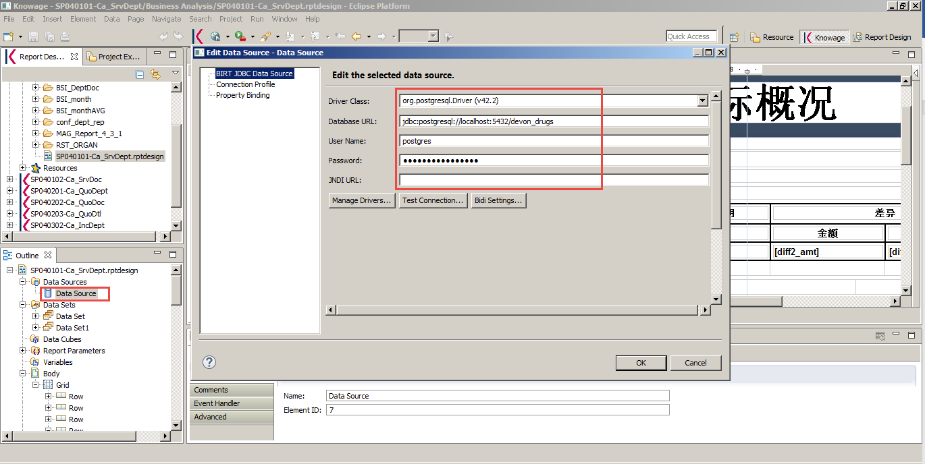

Fig.4-1 Set data source for birt report

This is the setting on local side where the knowage birt report designer is installed.

For maintenance, the postgresql server settings(database url, user name and password) should be same as the server side.

- Create dataset for birt report

Datasets can be added as user want.

User should make the query for dataset and set the parameter for datasets(input parameters are written as ‘?’ and the order of them are saved as the parameter’s order). (Fig.4-2)

Datasets are used for elements in birt report.(Fig.4-3)

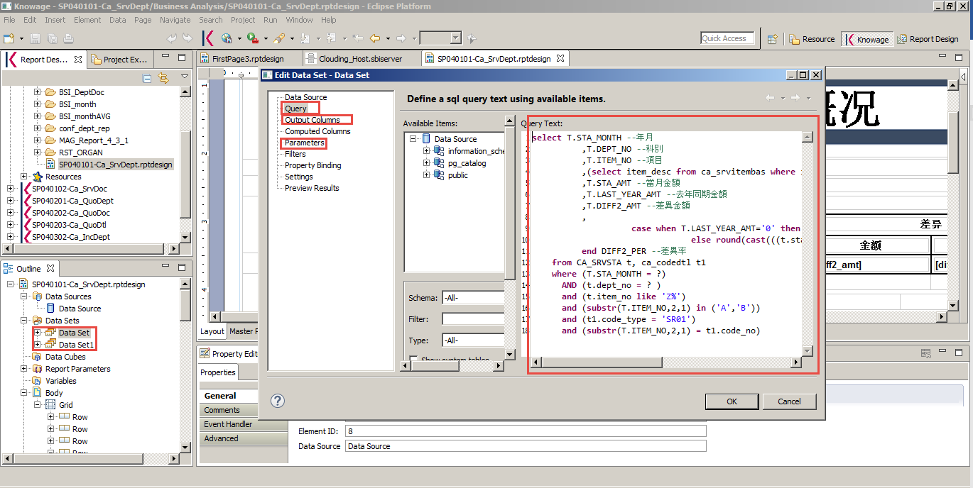

Fig.4-2 Dataset for birt report

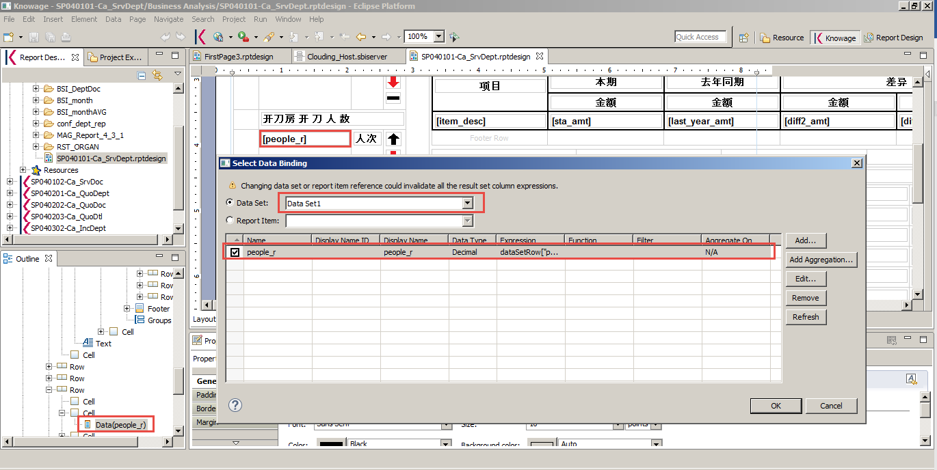

Fig.4-3 Dataset column with element

- Jasper reports

Jasper reports is for sub reports for birt report and can be installed on knowage server directly.

They can be navigated from Knowage birt report designer.(Fig.4-4)

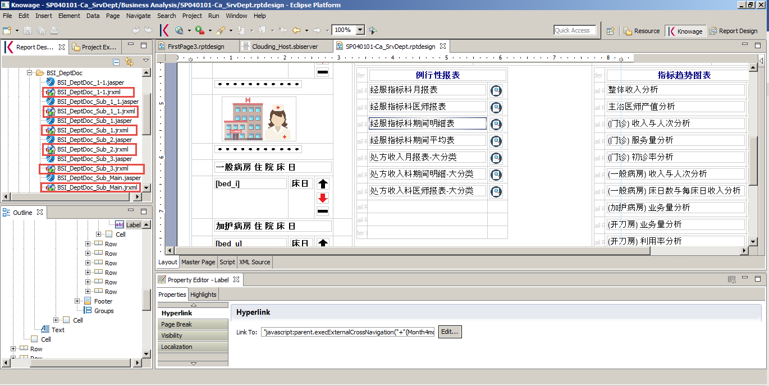

Fig.4-4 Navigate jasper report from Knowage birt report designer

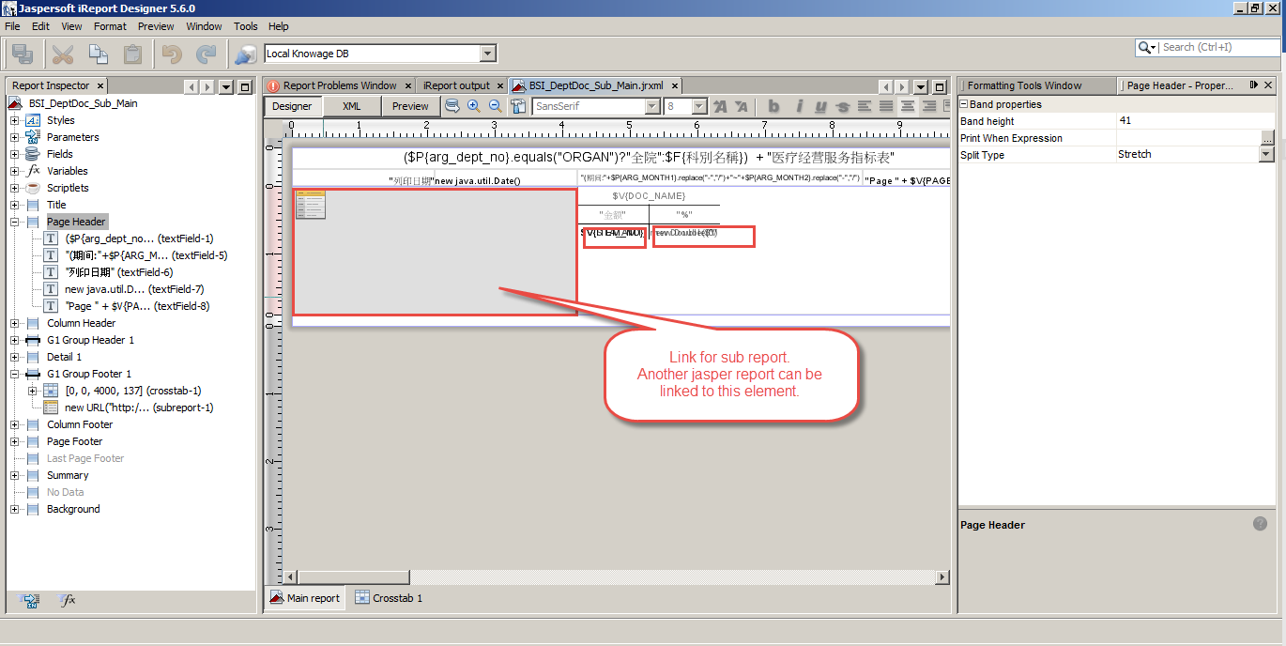

Fig.4-5 Jasper report design

- Server settings to upload birt report and jasper report

Server information should be set to upload birt report and jasper report. (Fig.4-6)

When user is going to upload the report, user can upload it easily using the server information.(Fig.4-7)

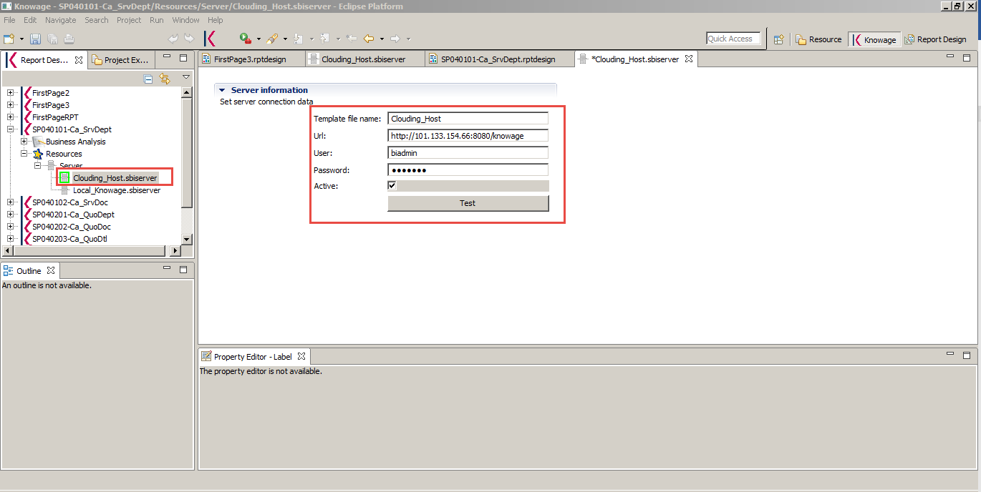

Fig.4-6 Knowage server settings

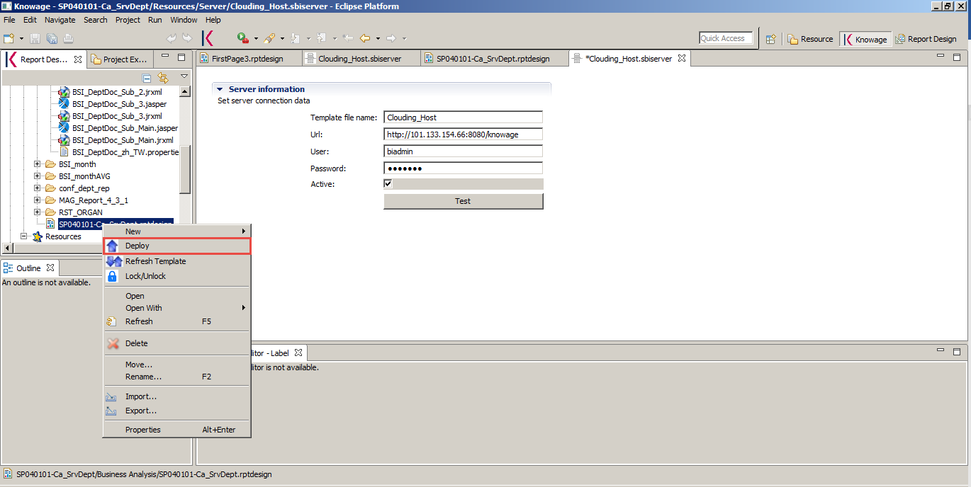

Fig.4-7 Deploy report to Knowage server

- Cross links

Cross links information are written in java script.

"javascript:parent.execExternalCrossNavigation(null, null, 'CROSS_BSI_Month')‏"

This is for non-parameter links for cross navigation.

"javascript:parent.execExternalCrossNavigation("+

"{Month4incomestatementRange:'"+Formatter.format(BirtDateTime.addMonth(params["argMonth"].value, -11), 'yyyy-MM')+"'}"+

", null, 'CROSS_incomestatementRange');"

This is for parameterized cross link.

The cross links should be set on Knowage server so that the link information is available when run it on Knowage server.

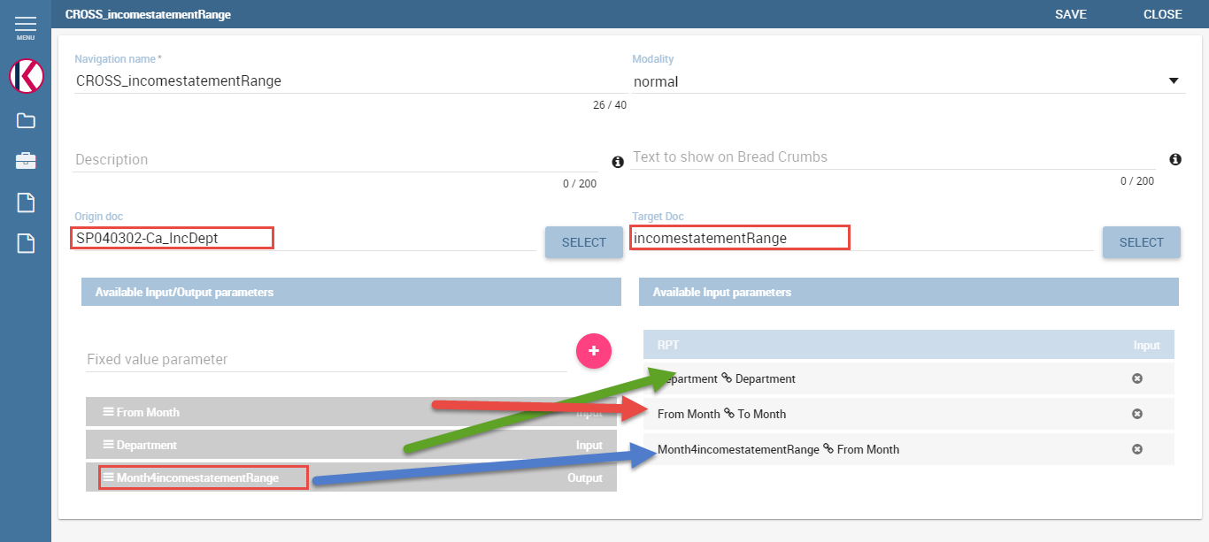

Fig.4-8 Cross links on Knowage server

5. First page

First page is designed using birt report to have links to original knowage documents with good UI.

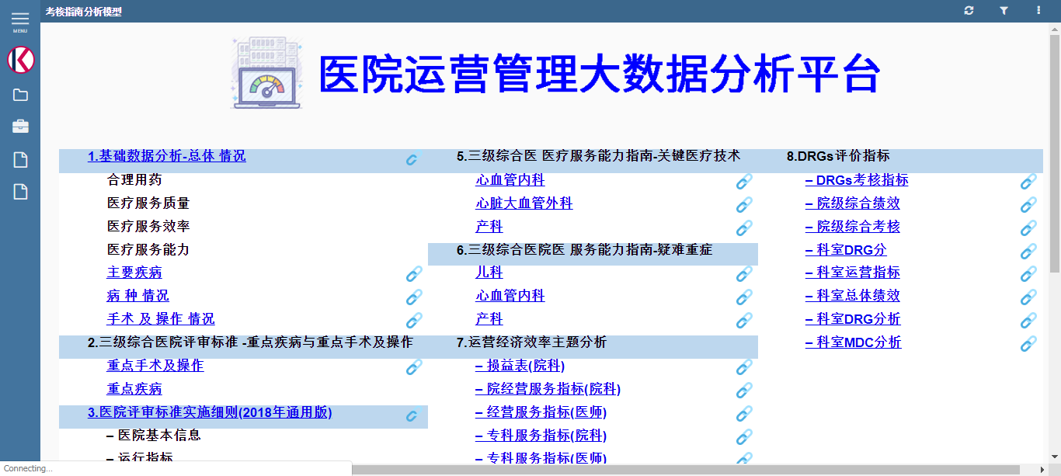

Fig.4-9 First page on Knowage server

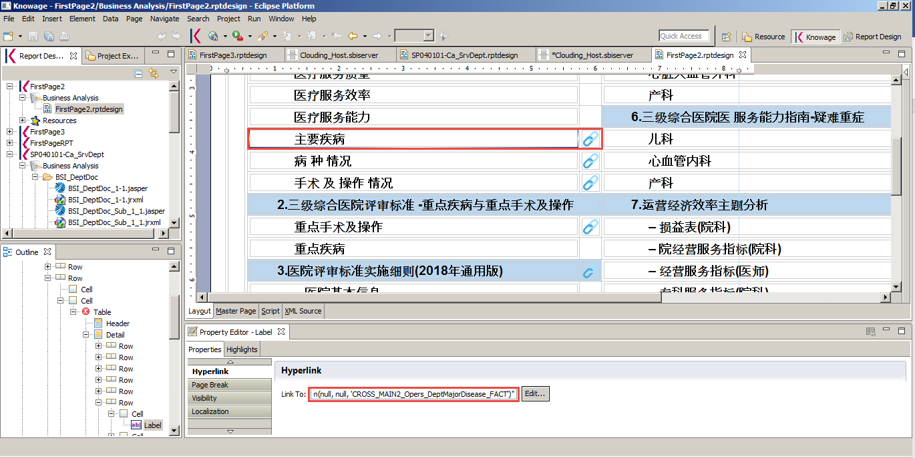

Fig.4-10 First page design on Knowage birt report designer

Cross links should be added on Knowage server.(Fig.4-11)

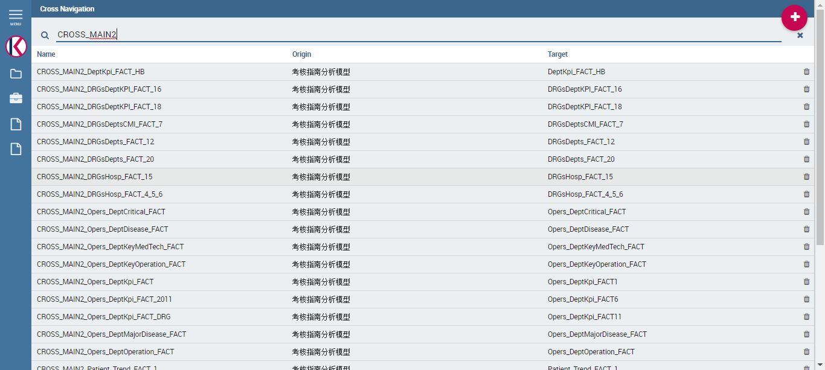

Fig.4-11 Cross links on Knowage server for first page

5. Olap Document

- Mondrian schema

Mondrian schema for business model should be added on Knowage server.(Fig.5-1)

Upload mondrian schema xml on Knowage server(Fig.5-2)

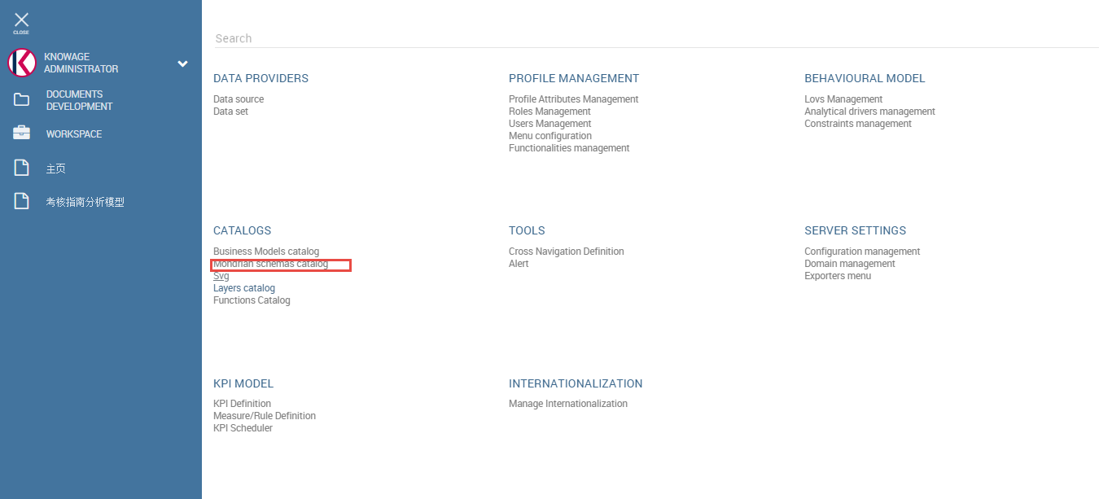

Fig.5-1 Mondrian schemas catalog

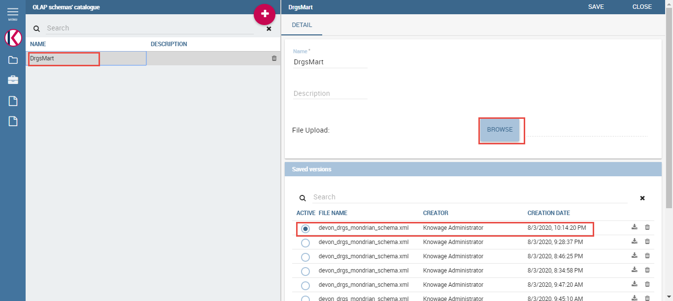

Fig.5-2 Upload Mondrian schema xml

Mondrian schema xml has following structure(Fig.5-3)

Create Olap document from Generic document menu.(Fig.5-4)

Link olap document template to olap document. (Fig.5-5)

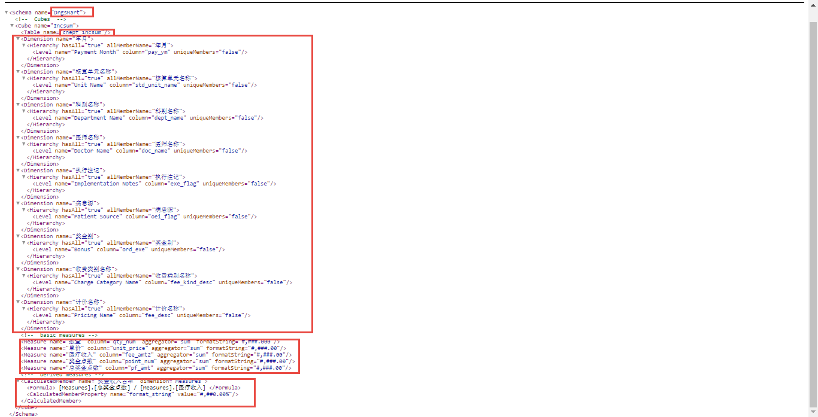

Fig.5-3 Mondrian schema xml

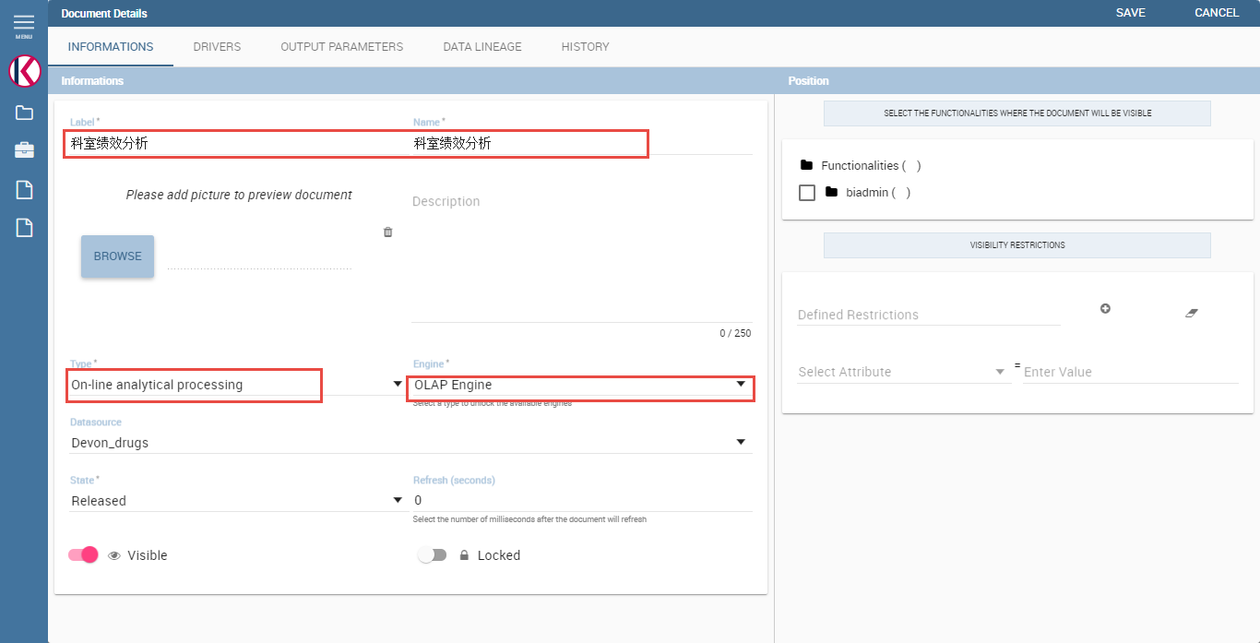

Fig.5-4 Olap document creation

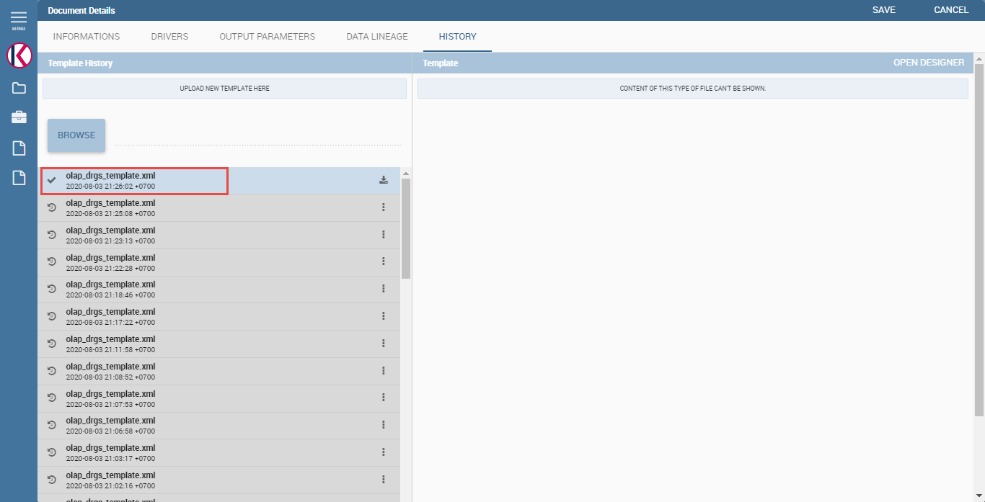

Fig.5-5 Link olap document template

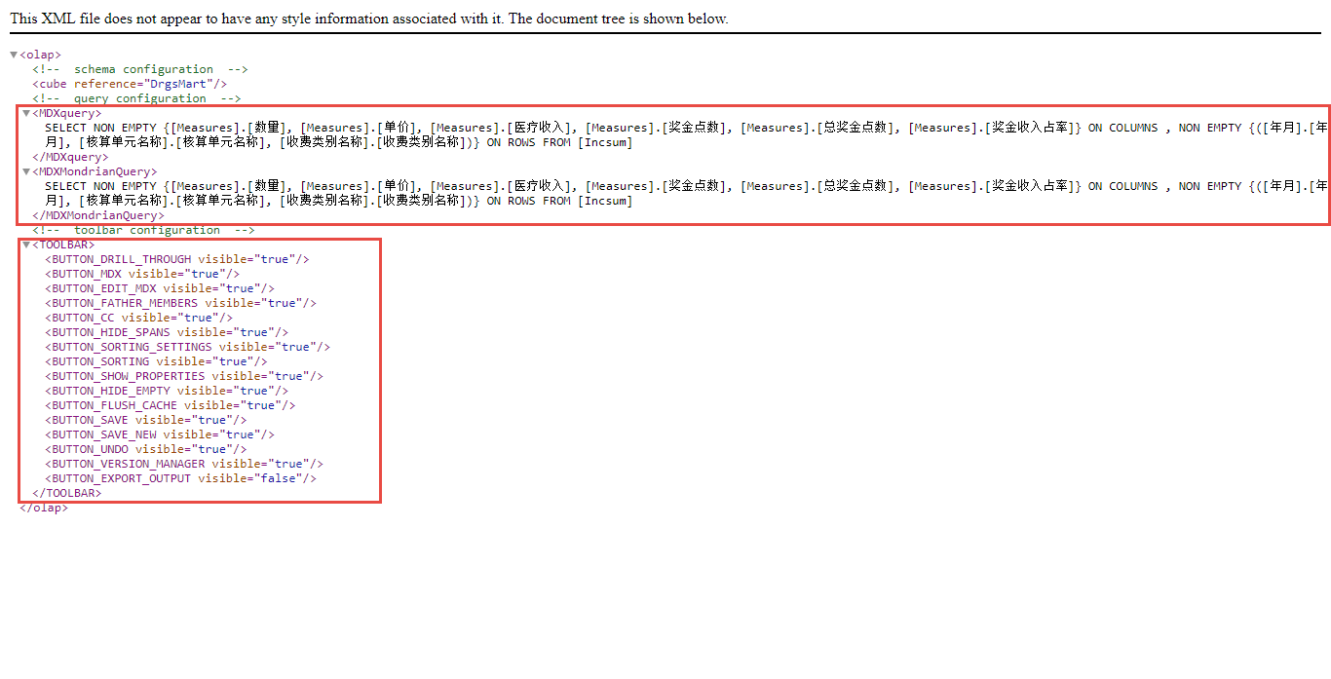 Fig.5-6 Olap document template xml